**Caribbean Fury**

Caribbean Fury is a small Battleset comprising five CMO scenarios. Focusing largely on the struggle between the US and some small NATO elements against Soviet sponsored uprisings, terrorism and outright warfighting from several Central American and Caribbean countries.

Although this region is America’s back yard, the commitment of forces here equates it to a backwater. In the early hours of the conflict there can be overwhelming American force available, but most of it is tagged to deploy around the globe leaving second and third string elements to deal with the mess the Soviets have made. NATO allies are also present but they are short on resources and long on demands, some of which the Americans don’t agree with.

To the Soviets, the Caribbean is a sideshow, a distraction where its proxies can tie down American forces at little or no cost to the main effort in Europe. Beyond a few squadrons of modern aircraft and some air defence systems provided to Cuba, most of the effort is behind the scenes. Venezuela however, is a wild card and has not accepted the Soviets plan to the degree Moscow wanted. Caracas will still be a problem that Washington will need to deal with though.

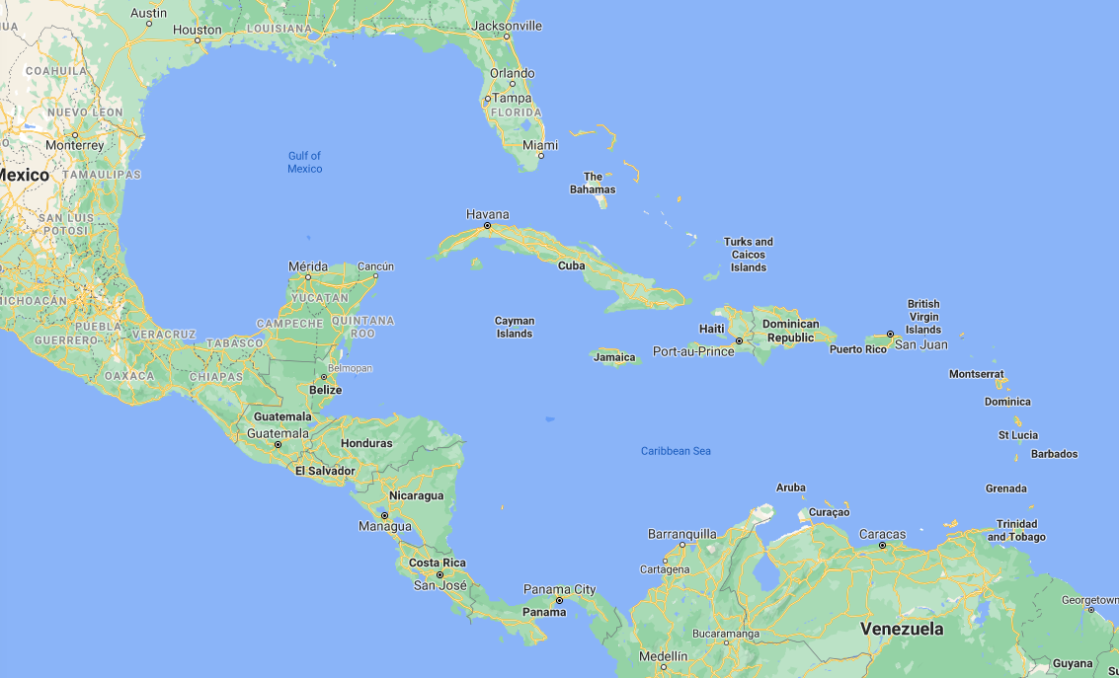

Of the five scenarios, three are played from the Soviet side and two from the NATO side.

1. Hot Tamale’s, War erupts across the Carribian
2. Retribution, After Cuba has been supressed, US Special Forces pay a visit
3. Rumble in the Jungle, An effort is made to knock Central American countries out of the war
4. Show of Force, Stealth is needed to take out a Soviet base in Venezuela
5. Caribbean Cruise, Convoy escort operations from Panama to the Atlantic are threatened