**Indian Ocean Fury 1: Persian Pounce.**

13 Feb 1994, 1400 Zulu, 1800 Local

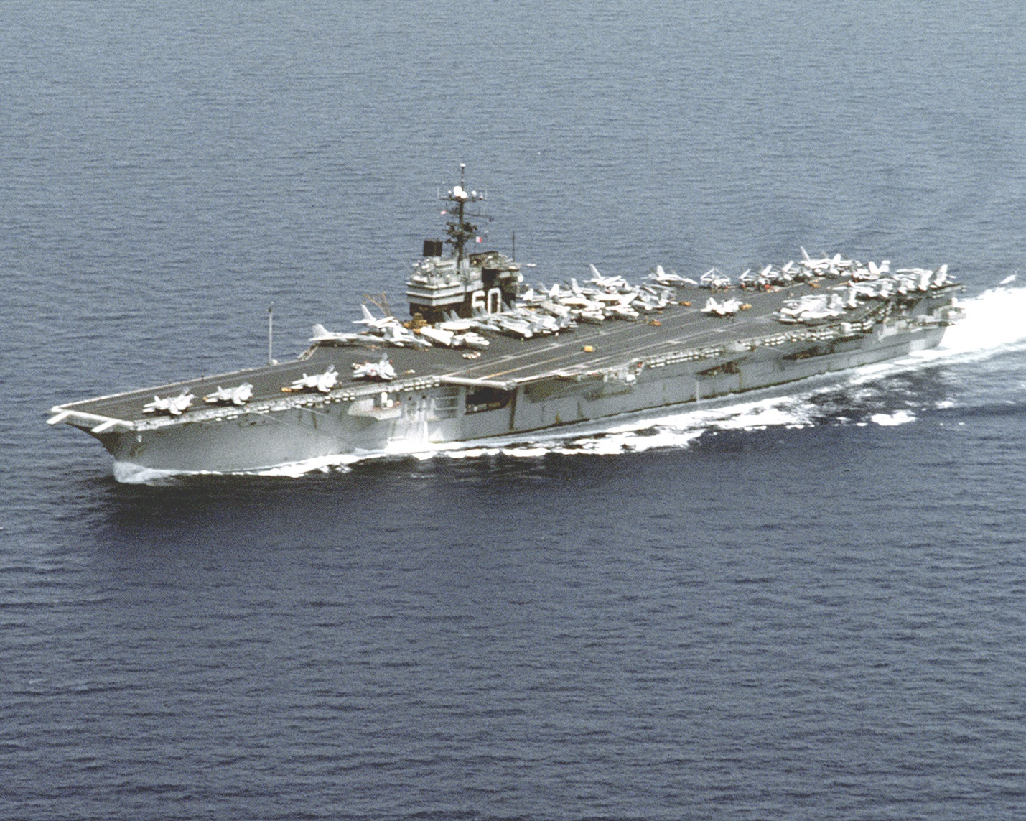

You’re commanding the US 5th Fleet on the flagship *USS La Salle* based in Manama Bahrain. Your command was re-established Dec 93 (18 months earlier then it historically was) and oversees both afloat and shore-based units that rotationally deploy or surge into the Gulf. Units under your command are American (USN, USMC, USAF and US Army), British, French, Italian, Spanish, and Australian. Although much of your force is off on independent operations in the Indian Ocean and beyond, the primary responsibility in this region is safe and secure passage of commercial shipping through the Persian Gulf and Straights of Hormuz.

For this task you have: The *USS Saratoga* CVBG patrolling in the Gulf of Oman; 16 independent warships from several nations patrolling different areas of the Gulf and Straights; one submarine; several support vessels; several air squadrons; and a mine countermeasures group.

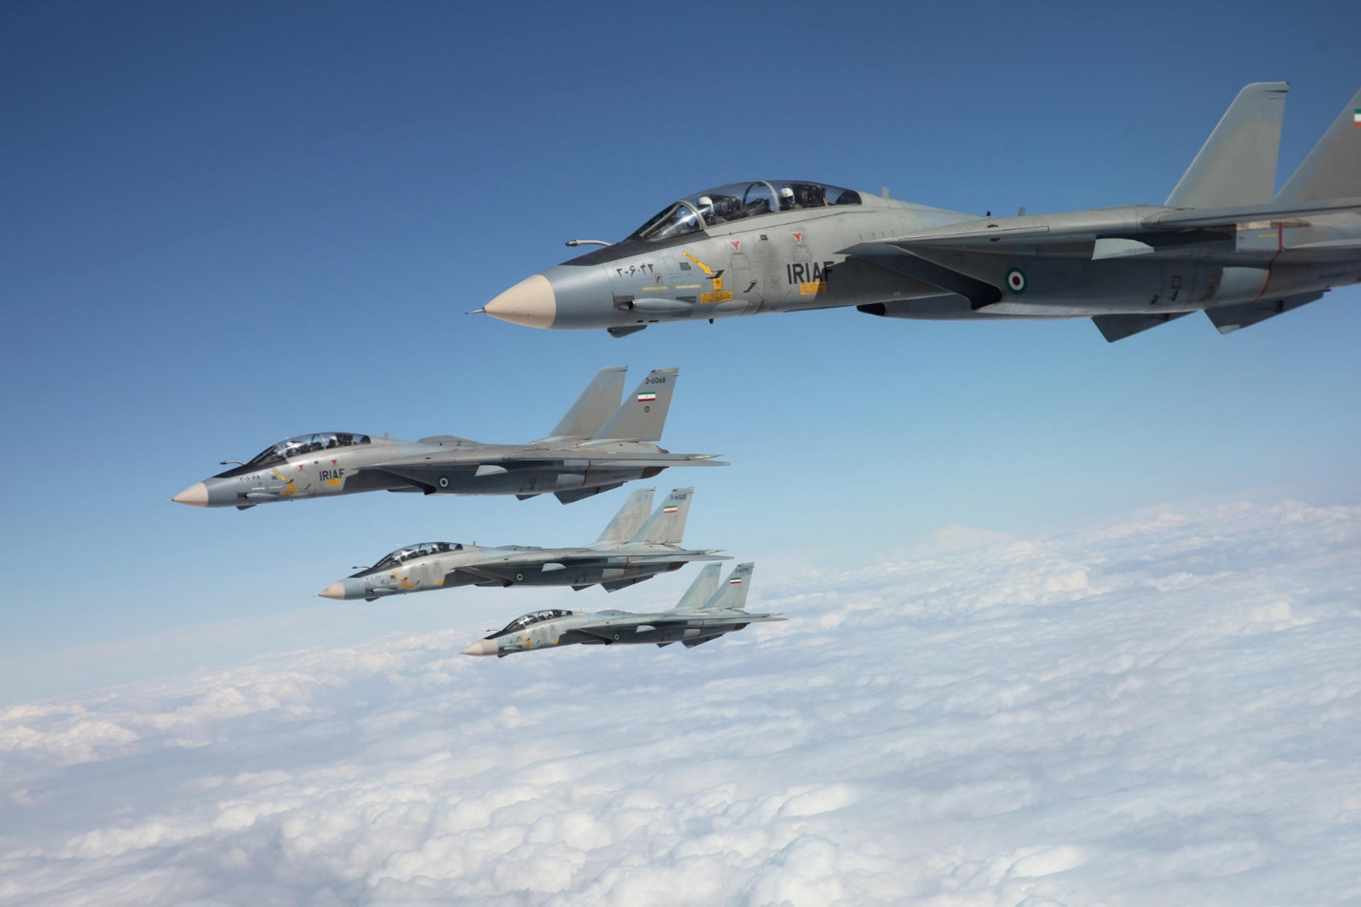

**Indian Ocean Fury #1** is an intense scenario with significant action early on as Iran, supported by Soviet advisors and visiting aircraft launch a surprise attack on shipping in the Persian Gulf. The first few hours will see a surge of aircraft and missiles into the Gulf and Straits of Hormuz. Casualties will be high. Diplomatic efforts behind the scenes quickly kick in and over a few hours Gulf States join the fight with various levels of enthusiasm.

The player will receive direction which will be difficult to enact as the tactical situation interferes with strategic and operational imperatives.

