**Indian Ocean Fury 2: Mozambique Madness**

13 Feb 1994, 1300 Zulu, 1600 Local

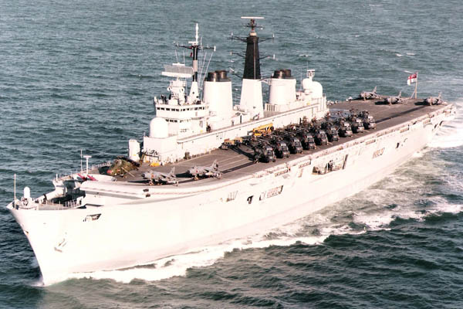

You’re commanding the HMS Ark Royal Battle Group which has just completed a long scheduled port visit to Cape Town South Africa. Predominantly this was a diplomatic mission to welcome the post-Apartheid nation back into the fold of the western world, but it was a good break from patrolling in the Gulf of Aden. Your force is not ready for operations at the moment, in fact only three of the six ships under your command are currently in company.

As you travel up the Mozambique Channel between Africa and Madagascar, you begin to receive disturbing news from Europe and North America. After conferring with your staff and the Captain of the Ark Royal, you direct them to make contingency plans should you be directed to cut your tour with CTF-150 (Combined Task Force 150 – the international force protecting shipping in the Gulf of Aden and African coast) short and head to either the Persian Gulf or the Mediterranean. At least things should be quiet for the next few days of passage north.

**Indian Ocean Fury #2** follows the path of the Ark Royal and other forces along the east coast of Africa as the area crawls into World War Three. Soviet proxy states pop up unexpectedly while the hunt is on for some elusive surface units hiding in this remote and isolated area.

