**Indian Ocean Fury 3: Socotra Scramble**

15 Feb 1994, 0100 Zulu, 0400 Local

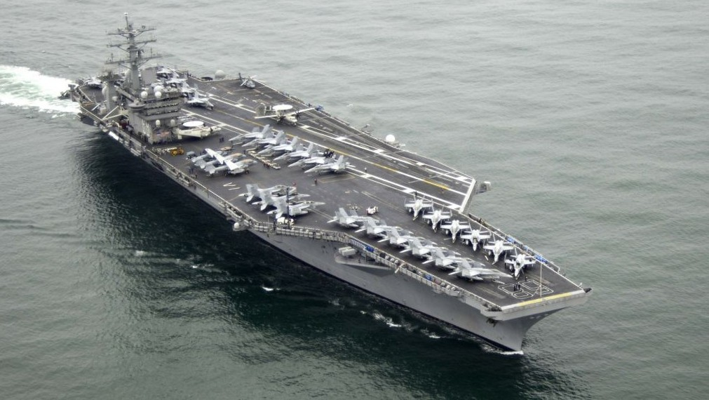

You’re commanding the USS *Nimitz* CVBG and have been tasked to steam at maximum possible speed north to join 6th Fleet in the Mediterranean. Things are interesting in the Indian Ocean but positively frantic in the Med.

In this scenario you will need to assemble your Battle Group, neutralize several layers of enemy defences, proceed through restricted, hazard laden waters to enter the Red Sea on your journey to the main theater of operations.

**Indian Ocean Fury #3** demonstrates the hazards that restricted waters present to large warships as the USS *Nimitz* and her escorts first strike at the Soviet base on Socotra then transit through the very narrow channel of the Bab al-Mandab. French forces at Djibouti prove critical, as do some key assets that are only available briefly.

