**Indian Ocean Fury 4: Gate of Tears**

19 Feb 1994, 0400 Zulu, 0700 Local

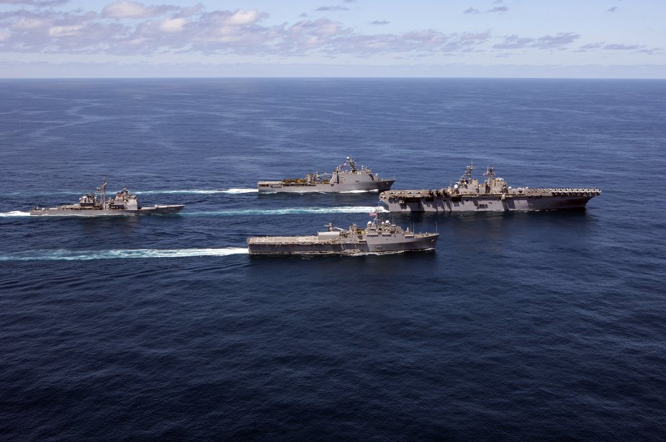

You’re commanding the newly formed CTF 155 combining diverse forces to secure the island of Socotra and the Bab el-Mandeb (BeM), the narrow gateway between the Red Sea and the Gulf of Aden. Your forces will conduct several amphibious and airmobile operations while simultaneously fighting for control of the air and sea in this vital maritime choke point.

**Indian Ocean Fury #4** has the player commanding a newly formed task force which includes the HMS Ark Royal group, some USN amphibious forces, a collection of French forces from across Africa and various air units in the region of the BeM.

After conducting an amphibious assault on the island of Socotra, the player will need to secure the area of the BeM through more amphibious and airmobile operations. Simultaneously there are some delicate diplomatic events happening which the player will play a hand in.

