**Indian Ocean Fury 5: Hormuz Hoedown**

18 Feb 1994, 1900 Zulu, 2300 Local

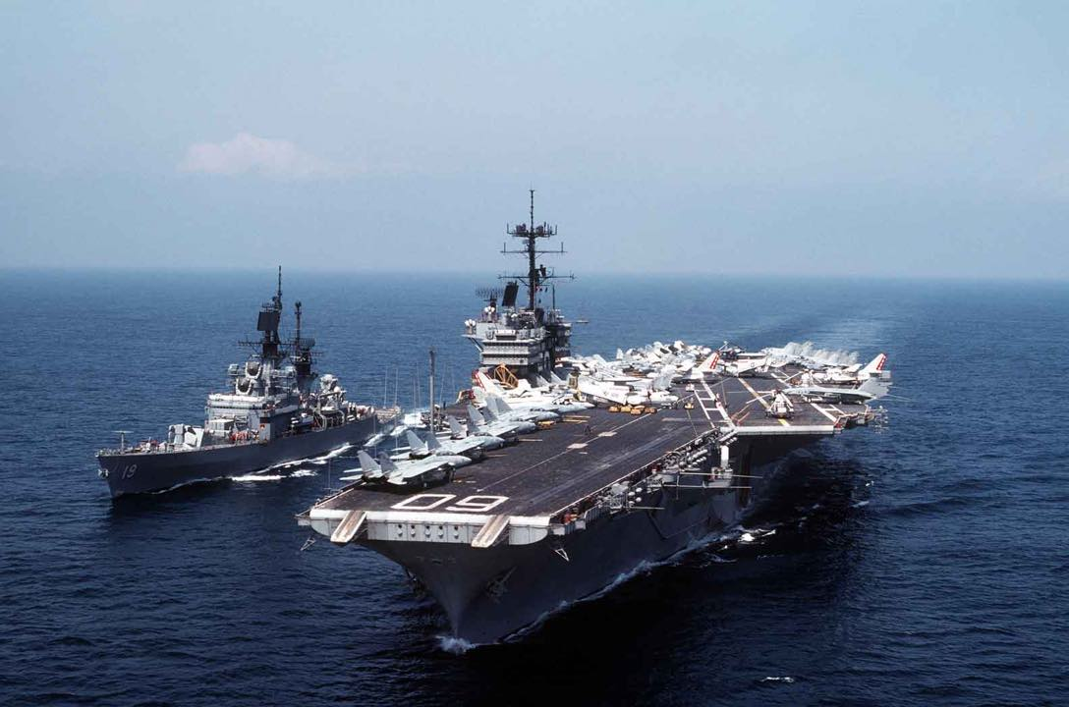

You’re commanding the newly formed CTF 154 centered on the USS *Saratoga* CVBG and combining all forces in the Persian Gulf region. Your primary task is to open the Straits of Hormuz to unrestricted navigation, but a critical and essential secondary task is to tie down Soviet and Soviet aligned forces (primarily Iran) so they cannot interfere in other theatres, particularly Syria and the Mediterranean. Finally, you must impress Saudi Arabia to commit to the conflict on our side, while preventing the spread of the war.

The Indian Ocean is a secondary theater and you cannot expect many reinforcements. Commander 5th Fleet will deploy to Socotra Island once it is clear, from there he will fight the larger battles in the Pentagon, but right now more forces and supplies are leaving the area then are arriving.

**Indian Ocean Fury #5** if the player did not understand that the Indian Ocean was now a secondary theater of operations, this scenario will demonstrate that point clearly. With a depleted and limited escort, the *Saratoga* must gather newly assigned forces arriving from as far afield as Australia and Singapore before making a strong push against the defences in the Straits of Hormuz.

Of course, the Iranians and their Soviet friends have other ideas in mind. Mines, air defences and small boat swarms are only the start.

