**Mediterranean Fury 1: The Road to Byzantium.**

13 Feb 1994, 1215 Zulu, 1415 Local

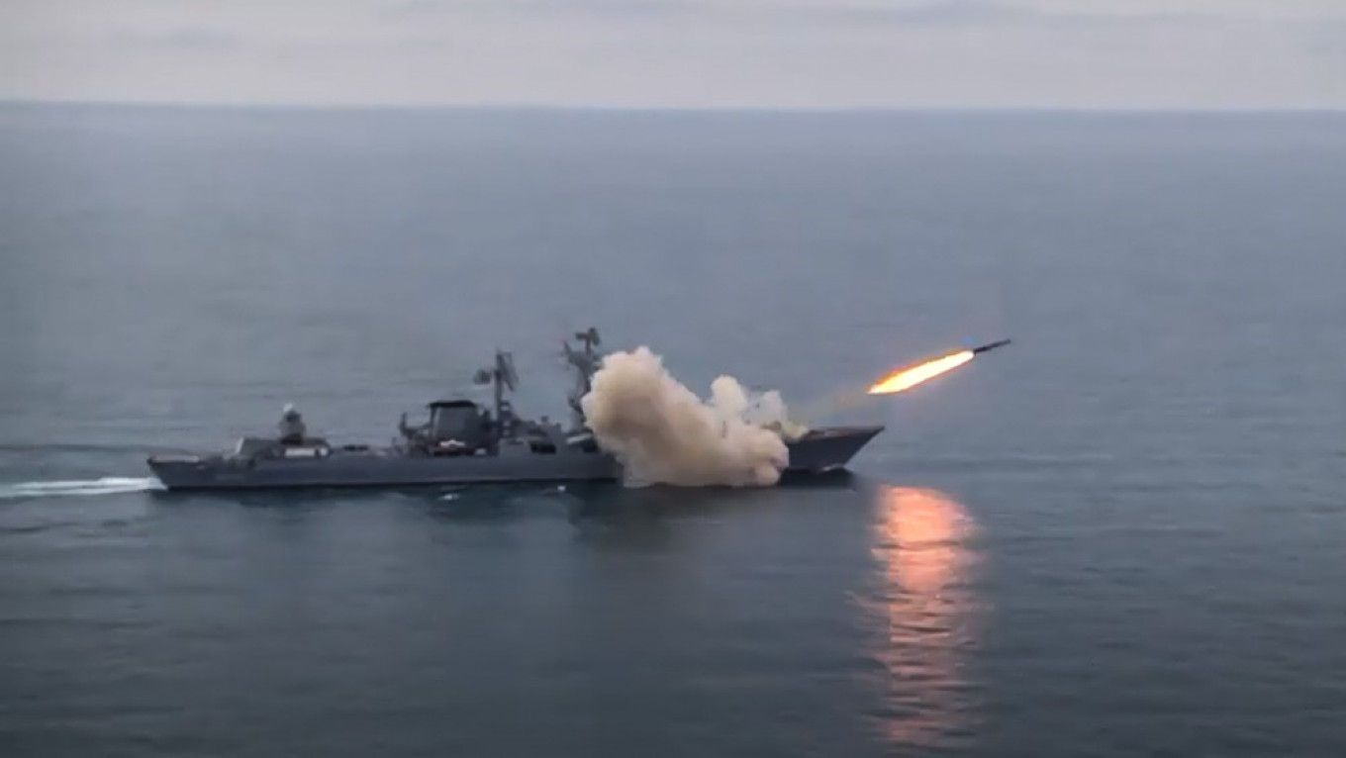

You are the Commander of the South Wester Direction HQ in Vinnitsa in Central Ukraine. You report directly to the Soviet High Command in Moscow and have many responsibilities; however, today in the opening moments of the war you have one focus – Turkey.

You’ve been aware of the upcoming campaign for some weeks now, and your key staff for the past month, but your subordinate commanders have only had a week to prepare, and the formations involved were only notified in the past days. Division commanders were told yesterday, and soldiers were being rounded up even now, minutes before the fighting begins.

You need to be in Moscow tonight to brief the President, so your deputy is now at Yalta taking personal charge of the operation. His job, if not his life, depends on seizing the Bosporus in the next 48 hours – then reinforced by mechanized forces from the 32nd Army Corps (Crimea Corps), supported by the 24th Air Army and the Black Sea Fleet – the Dardanelles within the week.

There are many supporting activities which will be exposed as required but rest assured – you are not alone in this fight. Even now the wheels are in motion to help you achieve what many have tried and failed in the past.

Take your hammer and bang on the door – the Russians are coming!

***Scenario Name: Catherine the Great’s longest serving consort, Prince Potemkin, after securing control of the*** [***Crimea***](https://erenow.net/biographies/catherinethegreat/67.php) ***in the 1780’s erected an arch over the highway leading to the Balkans with the inscription: “This is the road to Byzantium,” provocatively reminding the empress of the enduring Russian ambition to control access to the Black Sea and be the successor to the Eastern Roman Empire. Once again Russia is using the Crimea as a springboard to seize the Bosporus and Dardanelles – once more the road is traveled***

**Mediterranean Fury #1** is a large and intense scenario. The player has strategic decisions to make which will affect the tactical outcomes of play. After gaining air and sea superiority over the Black Sea, the invasion of Turkey takes center stage. The Turkish response is hampered by an attempted, and possibly successful coup as well as some other intrigues which have been occurring over the past months.

Turkey is not alone however, however their long-mistrusted allies, the Greeks have been subjected so similar tactics by the Soviets. The Americans are sure to respond, but in what way?

