**Mediterranean Fury 2: Syrian Surprise.**

13 Feb 1994, 1300 Zulu, 1500 Local

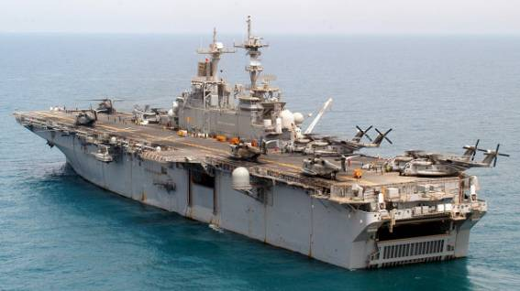

You are commanding an ESG (Expeditionary Strike Group) centered on the USS Kearsarge and the 22nd Marine Expeditionary Unit (MEU). In your 4th month of patrolling the Mediterranean you were about to commence an amphibious exercise with the USS Iowa using primarily British forces as the opposition. That all changed about an hour ago when you received the DEFCON 4 message from Washington, and an accompanying NATO Alert state RED.

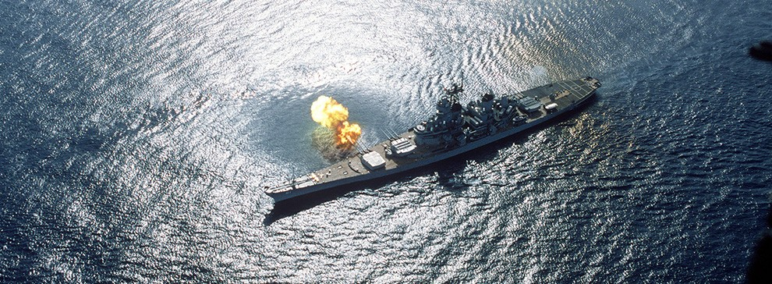

**Mediterranean Fury #2** puts the player in the position of rapidly transitioning from a peacetime exercise to a wartime defensive. Syria, with Soviet assistance strikes hard and fast. The first few hours are tense but as NATO musters its plentiful resources and gets organized, the player has a chance to seize the initiative.

