**Mediterranean Fury 3: Syrian Surprise.**

14 Feb 1994, 1300 Zulu, 1400 Local

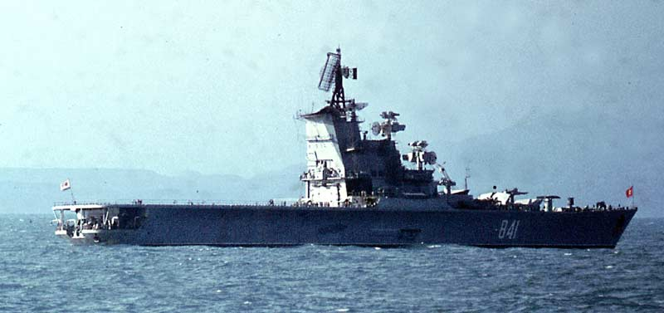

In the second day of the war, Libya remains neutral. Nobody is sure if that situation will last but the Soviet helicopter carrier *Leningrad*, along with escorts are anchored off Tripoli, and this is a major threat.

Your mission is to sink the Soviet Ship *Leningrad* and escorts, hopefully without causing war with Libya. Although this is a delicate task, you have significant force at your disposal, unfortunately these are very dispersed and if Libya enters the war unexpectedly, the balance of power will equalize quickly.

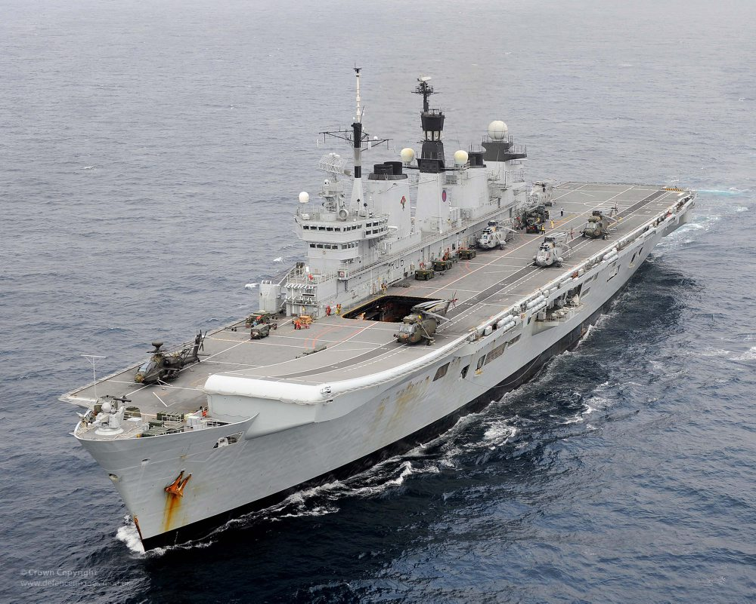

**Mediterranean Fury #3** is a difficult scenario. NATO has significant force but geographically they are dispersed from Gibraltar to Crete. The Soviets, and their allies in Libya and Algeria hold a thin but important edge based mostly on location and concentration of force.

