**Mediterranean Fury 4: Secure the Flank.**

16 Feb 1994, 1300 Zulu, 1500 Local

You are commanding 6th Fleet, a powerful but diverse force currently gathering in the Eastern Mediterranean Sea. With the assistance of the USAF’s 366th Expeditionary Air Wing in Egypt, more Turkish forces, Jordanians and another two F-16 Squadrons, you need to start the process of dismantling Syria’s ability to interfere with future operations

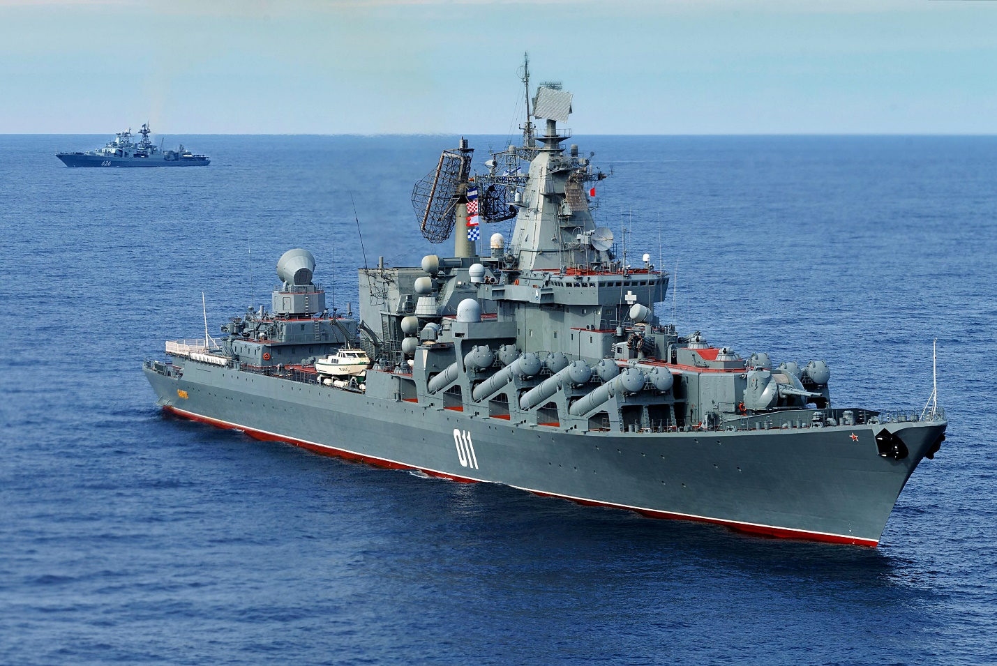

**Mediterranean Fury #4** represents the first chance NATO has to take the initiative. Syria’s Integrated Air Defence System (IADS) is formidable, and the degree of Soviet reinforcement is unclear.

A small Soviet naval task group centered on the helicopter carrier *Moskva* is leading a potent group of escorts and must also be destroyed

