**Mediterranean Fury 5: Serbia-right!**

16 Feb 1994, 1300 Zulu, 1400 Local

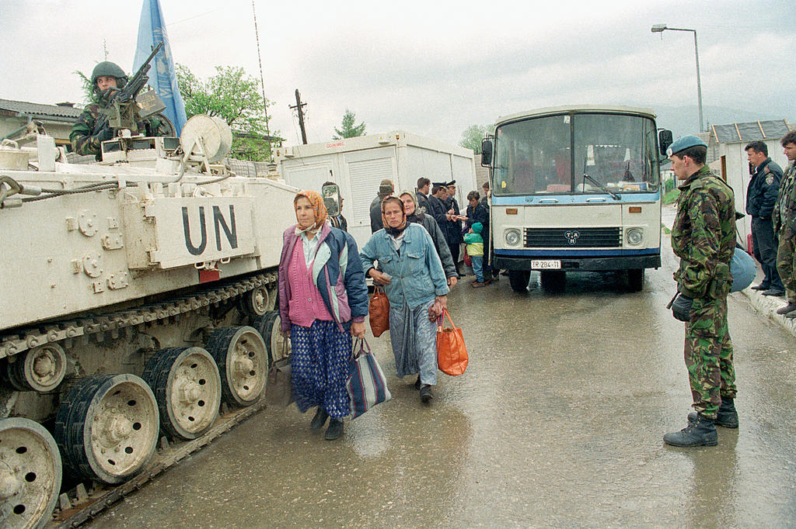

Three days into World War Three and you as **Commander 5th Allied Tactical Air Force (ATAF)** are now focusing your efforts on the Adriatic and Balkan situation. Commander 6th Fleet as Commander NATO Strike Force Southern Europe (STRIKFORSOUTH) has been given the task of cleansing the Mediterranean Sea of Soviet threats and neutralizing Libya and Syria. Commander Allied Land Forces South-Eastern Europe (LANDSOUTHEAST) is working the situation in the Bosporus and Aegean Sea. All three of these commands have been allocated land, sea and air forces and have effectively become regional Joint Commands, at least until the situation stabilizes.

The situation in the Balkans is complex; Slovenia is working hard at becoming a NATO member but has no military force to speak off, Croatia and Bosnia are being stabilized by [UNPROFOR](https://en.wikipedia.org/wiki/United_Nations_Protection_Force) (United Nations Protection Force), Serbia is being actively recruited by the Soviets but the provinces of Macedonia and Kosovo are on the verge of open revolt despite Belgrade’s oppression, and Albania is striving to be neutral but is riddled with organized crime. UNPROFOR is a large force but dispersed across the two countries and set up for stabilization, not warfighting, also several of the 40-odd countries making up its force of over 30,000 troops want no part in this war – and many others want their troops back. NATO’s Operation [Deny Flight](https://en.wikipedia.org/wiki/Operation_Deny_Flight) and [Sharp Guard](https://en.wikipedia.org/wiki/Operation_Sharp_Guard), the air and sea blockade of the Balkans, are still in place but their responsibilities and resources have fallen under your control.

For the past 72 hours your Area of Operation (AO) has been quiet – disturbingly quiet! The WP has not violated UNPROFOR airspace while the tempest of war goes on to the north, south and east, apparently content to hold down NATO forces while conserving their own. NATO on the other hand is not anxious to engage on another front at a disadvantage, and has been content to hold back and wait, its pulled back its Operation DENY FLIGHT forces to hold over the Adriatic in a desire not to provoke a reaction, while naval forces maintain anti-smuggling patrols. A phony war akin to the winter of 1939/1940 in France has developed. Although this may sound like a good thing – you’ve watched as forces flowed through and around your command without any real reinforcement being assigned to you – from your perspective that is not ideal. There are also some indications that the Soviets don’t trust their fraternal brothers in Romania and Hungary to do any heavy lifting.

That situation however is about to change. Just over 20 hours ago the small container ship ***MV Hansa Carrier*** enroute to Split experienced an explosion reported as a possible mine incident in Splitska Vrata Channel. She was carrying sundry goods for Croatian consumption but also many containers specifically to supply UNPROFOR forces.

So, SHAPE (Supreme HQ Allied Powers Europe) has directed Naples (AFSOUTH – Allied Forces Southern Europe) to conduct strikes into Hungary primarily to distract WP efforts in Germany; but also to exert pressure to deter WP operations in Syria and the Bosporus area and finally, to cover SNMCMG2’s (Standing NATO Mine Countermeasures Group 2) operation to rescue the ***Hansa Carrier.***

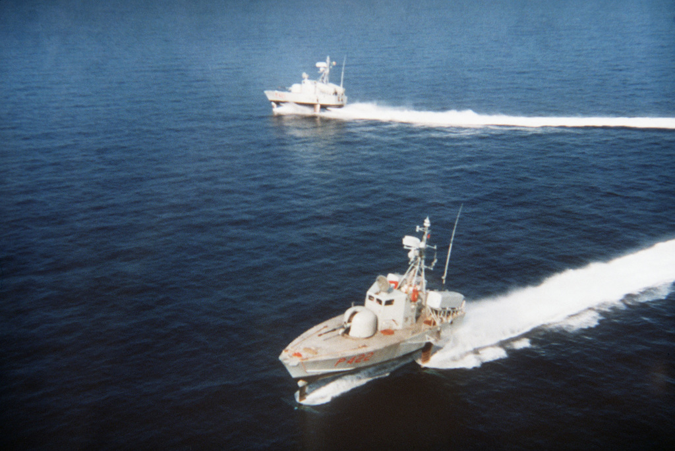

**Mediterranean Fury #5** places the player at the horns of a dilemma. Should the allied air forces proceed as directed and conduct strikes into Hungary, or should they prepare for a WP air and ground assault which the intelligence staff is warning against?

The end result is a complex and diverse scenario running the width of the Balkans and the breadth of the Aegean. Counter smuggling operations, rescue of UNPRFOR personnel, defending far flung locations and striking deep into WP territory are all part of the game.

