**Northern Fury 1: H-Hour**

13 Feb 1994, 1300 Zulu, 1400 Local

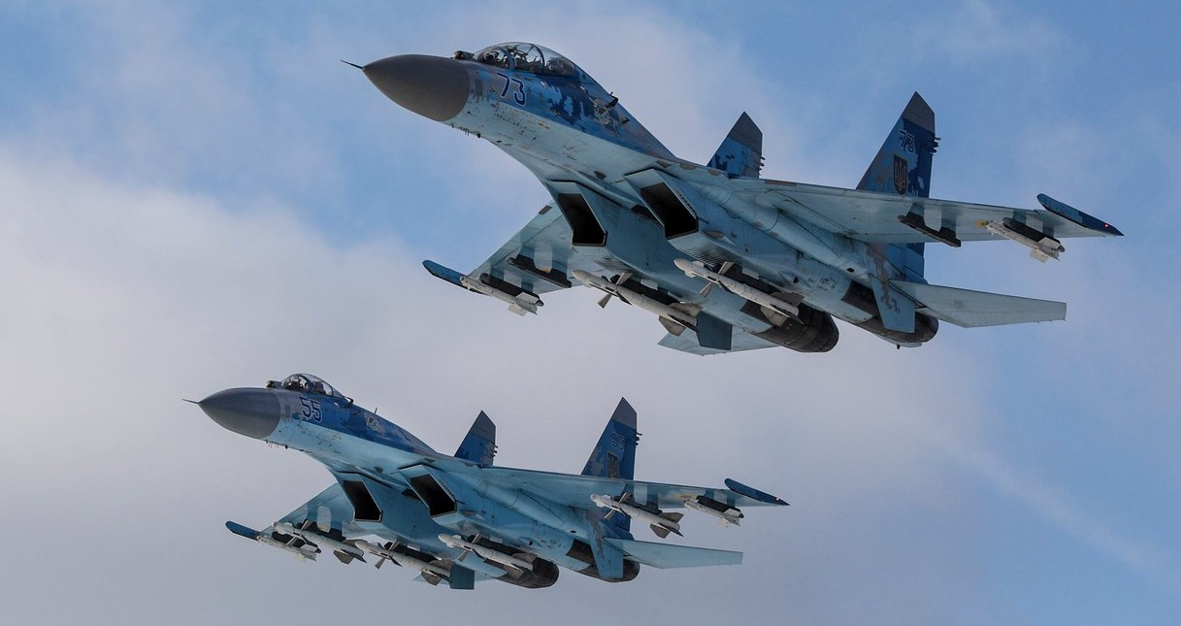

You are the commander all forces in Northern Norway. Allied Forces North Norway (AFNN) HQ is in Bodo Norway, this is a 'dual hat' organization which maintains National Command of Norwegian forces North of Orland and reports to Allied Forces North (AFNORTH).

Over the past 6 hours you have deployed 2nd Battalion of Brigade Nord forward to garrison Banak and recalled the Home Guard to garrison Kirkenes and other airports in Finmark province in order to facilitate a limited evacuation of the civilian population. Naval and Air forces have also staged forward and have gone to a high readiness posture.

The NATO AWACS flight normally allocated to AFNN has been deployed for the past two weeks in preparation for the Olympics and is ready to support operations in all respects.

It is a cold day off the North Cape, it is unlikely to stay that way!

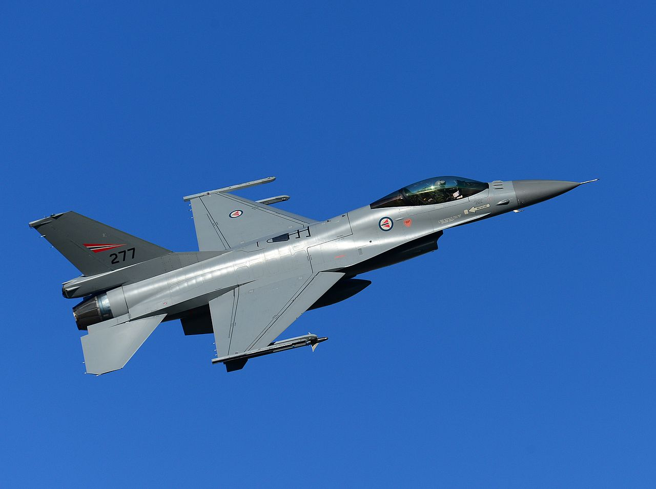

**Northern Fury #1** showcases the start of hostilities in North Norway. The battle will be intense and at times overwhelming as the Soviets put into play their plans to knock Norway out of the war. The old saying of ‘never fight a fair fight if you can avoid it’ applies to the attacking forces here – NATO is at a distinct disadvantage.

