**Northern Fury 10 -Eisenhower moves North**

19 February 1994, 0000 Zulu, 0000 Local

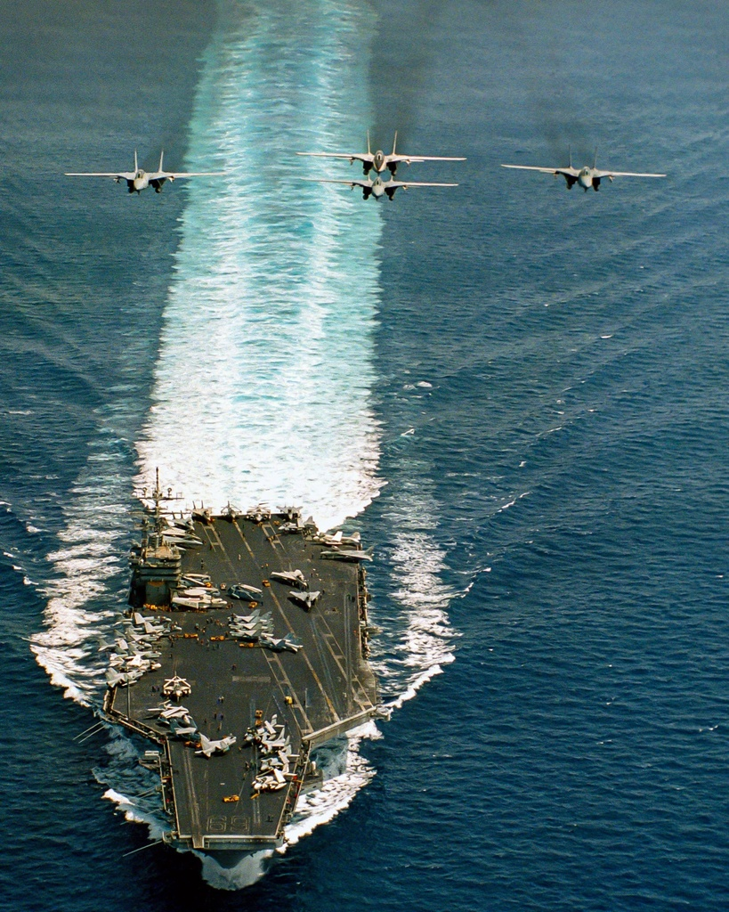

Entering the sixth day of a new global war between East and West, the situation is starting to stabilize. The ground war in Europe is still undecided but NATO forces in CENTAG (Central Army Group) have blunted the main Soviet advance somewhat, while the air war over Germany has seen the loss of hundreds of NATO aircraft.

The situation in the North Atlantic remains desperate. The rapid capture of North Norway and Iceland have allowed the Soviets to surge almost 100 submarines into the Atlantic. The USS Enterprise CVBG spent two difficult days blunting an attempt by the Red Banner Northern Fleet to interdict the sea lanes, she is now retiring, as are the major Soviet surface units, to replenish.

Now, as Enterprise steams South, the **USS Eisenhower**, after three days of hard fighting in the Mediterranean, has passed through he pillars of Hercules and is heading North. She and the USS Carl Vinson CVBG will strike at Soviet forces around Iceland three days from now.

This scenario is playable by either WP or NATO:

As the NATO player you must re-assemble and reinforce your BG as it is dispersed over several hundred miles due to replenishment demands. Two ships are still in the Med after conducting hasty repairs in Toulon, while a major portion of the force is escorting AOE Detroit and is just departing Rota. Most of your F/A-18s are in Rota Spain undergoing an upgrade, and you can expect replacements for your losses to fly in from NAS Oceania tomorrow. Finally, you must link up with HMS Fort George in a designated assembly area in preparation for your strike on Iceland.

As the WP player you have multiple submarines and other assets and your task is to disrupt the assembly of the Eisenhower BG and inflict casualties on NATO, while at the same time preserving your force.

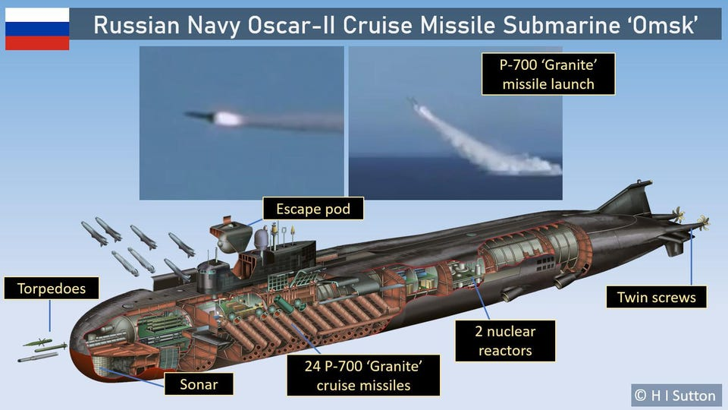

**Northern Fury #10** is a very asymmetric fight. The Ike (USS Eisenhower) has a long way to go, and a short time to get there, with many tasks and hurdles in her way. The Soviets on the other had will be hard pressed to compromise the impressive defences of a US carrier battle group – so they need to strike while the group is dispersed.

