**Northern Fury 11 - Changing of the Guard**

19 February 1994, 0800 Zulu, 0600 Local

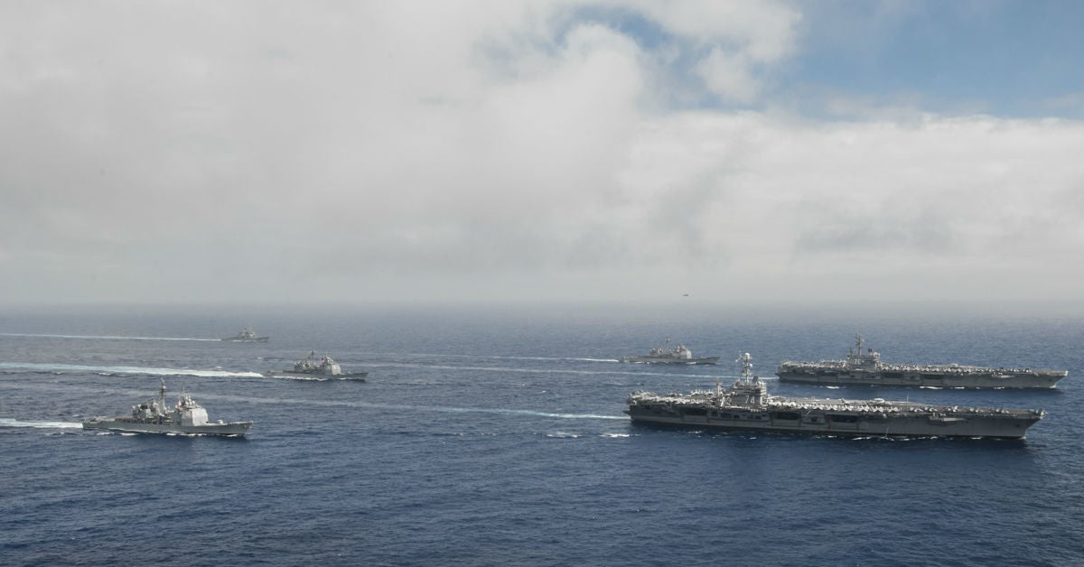

Morning on the sixth day of a new global war between East and West, the situation is starting to stabilize. The ground war in Europe is still undecided but NATO forces in CENTAG (Central Army Group) have blunted the main Soviet advance somewhat, while the air war over Germany has seen the loss of hundreds of NATO aircraft. Conflicts in the Caribbean, Mediterranean, Persian Gulf and Indian Ocean have stabilized in NATO’s favour, both the Panama and Suez Canals remain open and navigable.

The situation in the North Atlantic remains desperate. The rapid capture of North Norway and Iceland have allowed the Soviets to surge almost 100 submarines into the Atlantic. The USS Enterprise CVBG spent two difficult days blunting an attempt by the Red Banner Northern Fleet to interdict the sea lanes, she is now preparing to retire for re-supply and re-organization, as are the major Soviet surface units.

The USS Eisenhower, after three days of hard fighting in the Mediterranean, has passed through the Pillars of Hercules and is heading north. She will join the USS Carl Vinson CVBG to strike at Soviet forces around Iceland in three days.

Now it is time for the USS Carl Vinson to take center stage and relieve the embattled USS Enterprise and hold off any Soviet assaults until the Eisenhower arrives on scene.

This scenario is playable by either WP or NATO:

As the NATO player you must safely withdraw the USS Enterprise CVBG and replace it with the USS Carl Vinson CVBG in a holding area south of Iceland.

As the WP player you have multiple submarines and significant air assets at your disposal. Your task is to sink one or both US aircraft carriers.

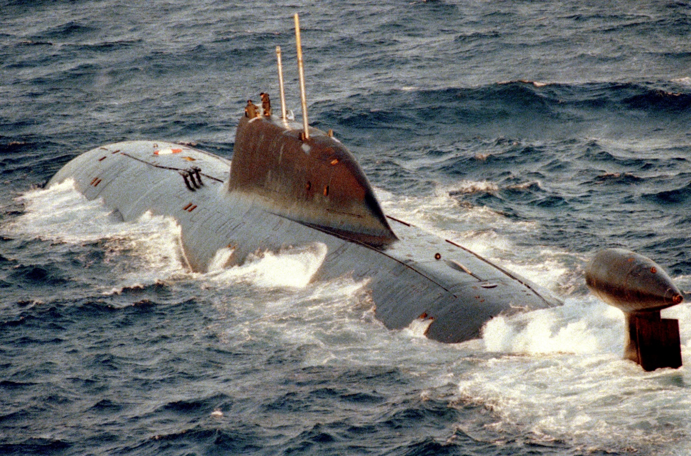

**Northern Fury #11** is the first opportunity the player has to operate two US aircraft carriers in the same area. All is not well however as ammunition stocks and available aircraft on the Enterprise are depleted, and the Carl Vinson still has a long way to go.

