**Northern Fury 12 - Command at Sea**

 19 Feb 94, 1300 Zulu, 11 Local

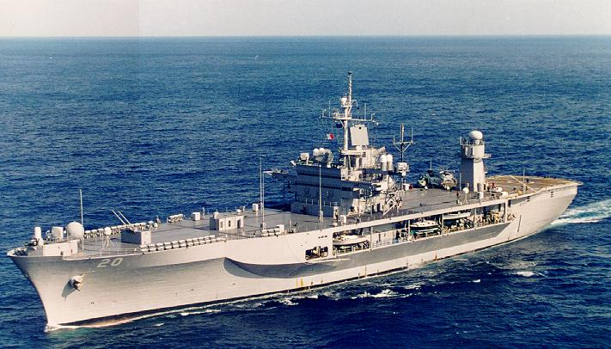

The situation in the North Atlantic remains desperate. The rapid capture of North Norway and Iceland have allowed the Soviets to surge almost 100 submarines into the Atlantic. The USS Enterprise CVBG spent two difficult days blunting an attempt by the Red Banner Northern Fleet to interdict the sea lanes, she is now preparing to retire for re-supply and re-organization, as are the major Soviet surface units. The USS Carl Vinson CVBG is moving up to relieve the Enterprise while the USS Eisenhower moves to join the USS Carl Vinson to strike at Soviet forces around Iceland in three days.

Meanwhile Commander of 2nd Fleet is on board the command ship USS Mount Whitney near the Azores, and the Soviets know it.

This scenario is playable by either WP or NATO:

As the NATO player you must maneuver and protect the USS Mount Whitney as it transports the Commander of the US 2nd Fleet (NATO’s CINCLANT) to a patrol area off the Azores.

As the WP player you have multiple submarines and valuable intelligence indicating that a ‘High Value Target’ is arriving in your patrol area.

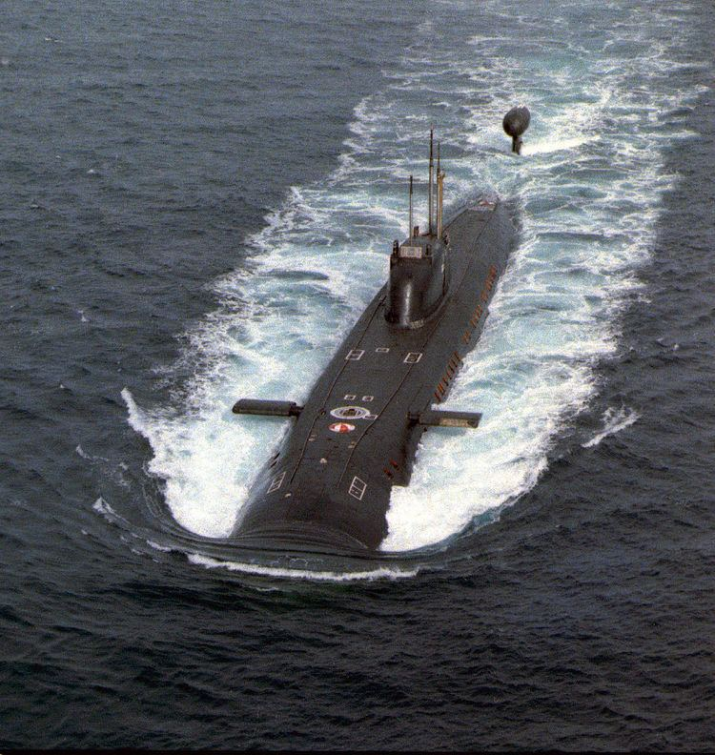

**Northern Fury #12** is a much smaller battle featuring assets and a situation that will give the player some difficult choices. The Soviets are certainly up to no-good in the area.

