**Northern Fury 2: X-Ray Station**

13 Feb 1994, 1300 Zulu, 1400 Local

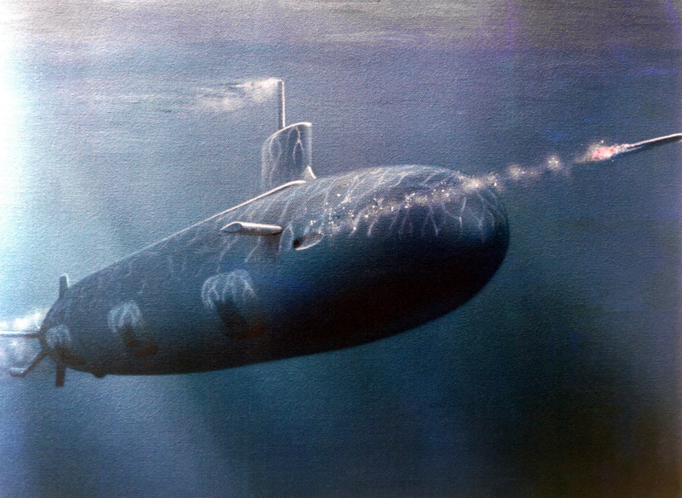

X-Ray Stationwas a long-standing patrol area for NATO submarines whose job it was to keep tabs on the Soviet Red Banner Northern Fleet, in particular the major surface units and the SSBNs.  Several US and occasionally UK submarines were on this station for almost **30 years!**

This scenario is playable by either side, as NATO your mission is to 'detect and survive' as WP your mission is to 'transit and kill'.

This scenario features the USS Connecticut, SSN 22. Although in actual history the Connecticut was commissioned in December 98; the alternate reality of Northern Fury has the Seawolf program proceeding as originally planned with SSN 21 laid down in 89 and ***29*** submarines of this class commissioned in the next 10 years. I assume that building would start slowly and only have 4 featured in the campaign, SSN 21 Seawolf, which you will encounter in the North Atlantic, SSN 22 in this and future scenarios, SSN 23 Jimmy Carter in the Pacific and SSN 24 Virginia in the process of commissioning in the Pacific. The current Virginia class was created as a replacement for the Seawolf and does not exist in Northern Fury.

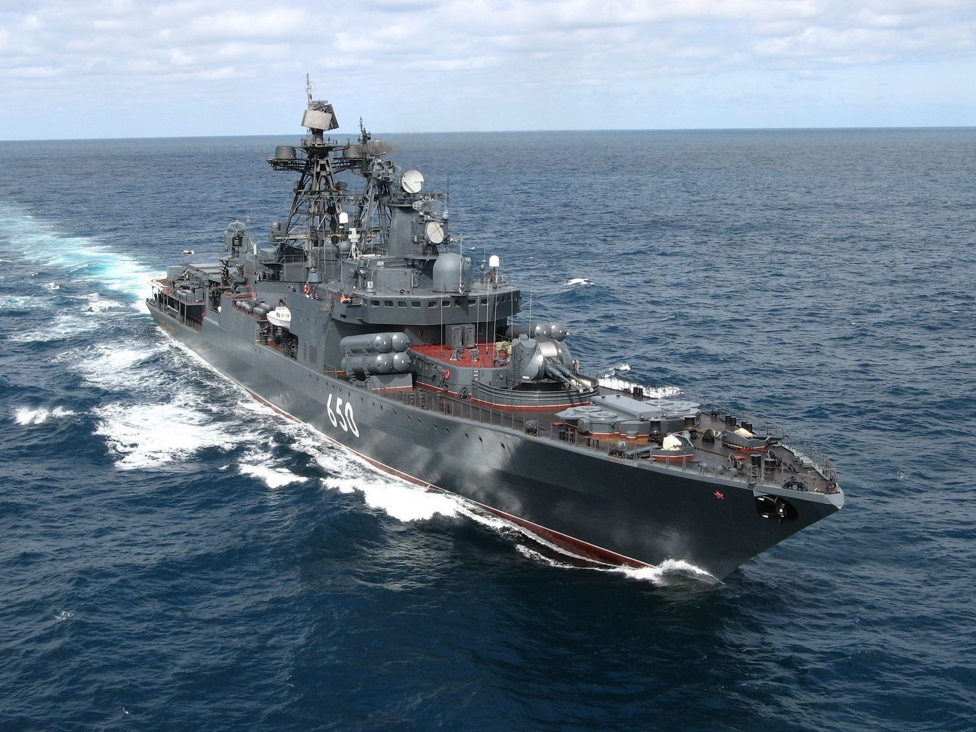

**Northern Fury #2** as the NATO player is quite difficult. You have submarines only and the Soviets know you are there – they don’t know where you are, but they are looking very hard. The Soviets face the challenge of finding some very elusive targets before key units are detected. The ‘cat’ in this game of ‘can & mouse’ is a sabre-toothed tiger, and the mouse fights back.

