**Northern Fury 3: Dagger to the Heart**

13 Feb 1994, 1200 Zulu, 0800 Local

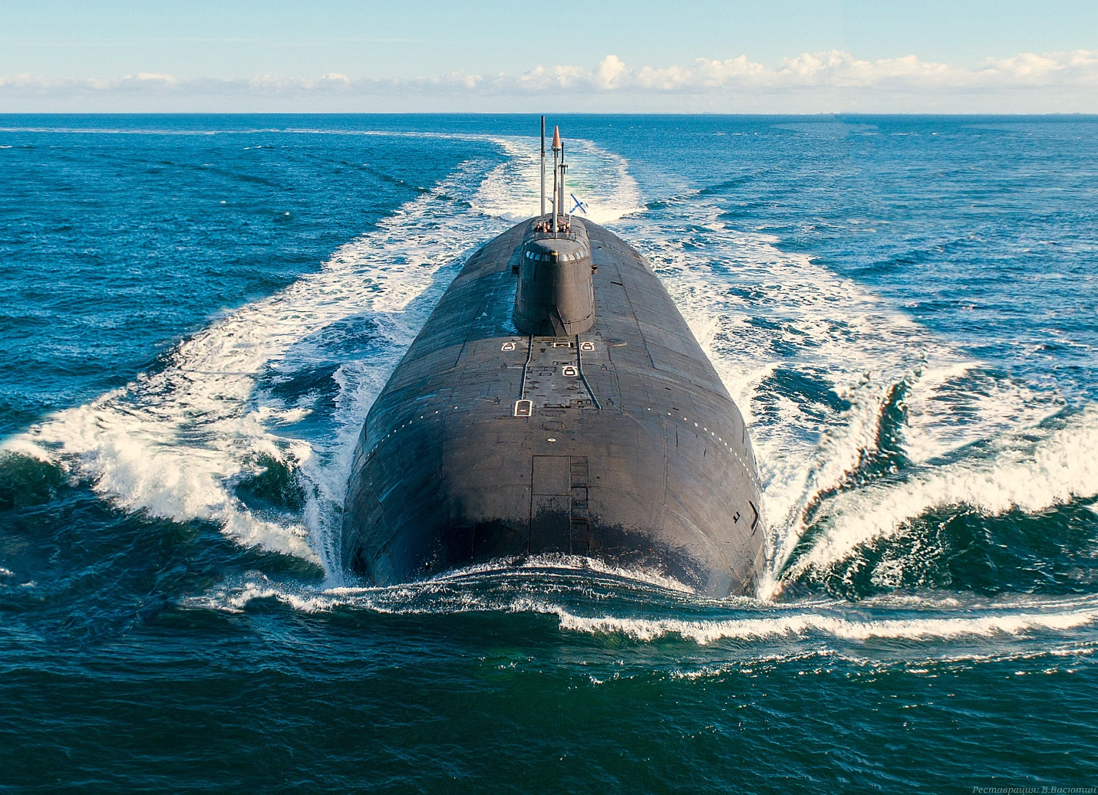

A quiet Sunday morning in New York Harbour, it’s cold and windy and the main topic of conversation at the Sandy Hook New Jersey, Coast Guard Station is the ongoing fiasco at the Olympics.

This scenario is playable by both sides. It is much more challenging from the US side and will also provide interesting threads to future scenarios, playing from the Soviet side is good fun but fairly easy:

As the Soviet player your mission is to disrupt maritime traffic in the New York Harbour area.

As the US player you are going about your business conducting routine Coast Guard patrols. The situation will develop.

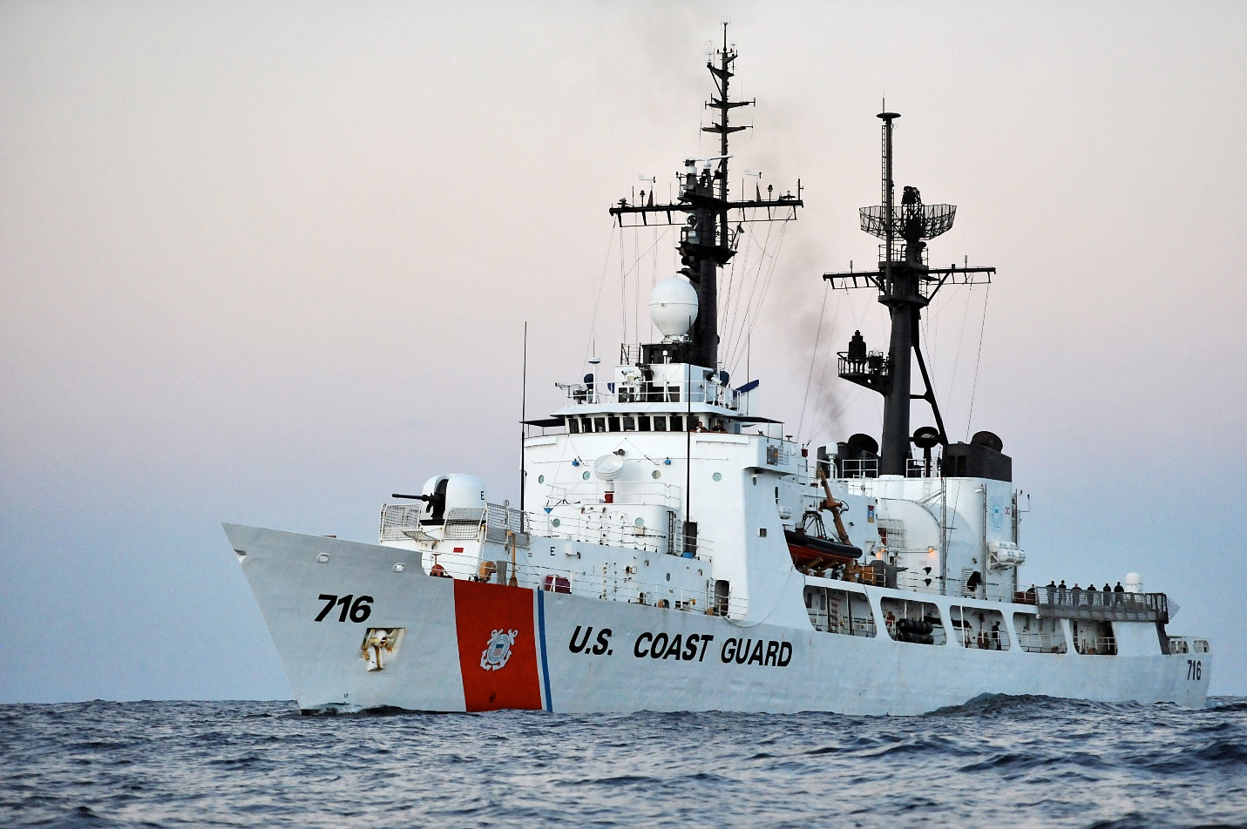

**Northern Fury #3** rapidly becomes a frenetic rescue operation for the US Coast Guard player. This scenario really shows some of the different methods the Soviets will use to distract NATO and particularly the US from the main effort in Europe. The American public will certainly be putting pressure on their government for continental defence after this scenario.

