**Northern Fury 4: Cold and Lonely Place**

14 February 1994, 1500 Zulu, 1400 Local

Jan Mayen is a Norwegian Island located in the Arctic Ocean 600 Km NE of Iceland and 1000Km West of the North Cape of Norway. The island boasts a local civilian population of 18, who are outnumbered more than 2:1 by a Norwegian Army signals detachment manning the weather station, radars and LORAN-C transmitter. In the last several hours a C-130 delivered some Air force ground crew to support a small detachment of F-5s and a P-3 which have just arrived.

**This scenario is playable by both sides**; however, it will be more challenging if you play NATO

The Red Banner Northern Fleet has two objectives, neutralize the radar and communications equipment and supplant it with Soviet equivalents; and the small gravel runway, **Jan Mayensfield**, which will be useful for future operations against Iceland.

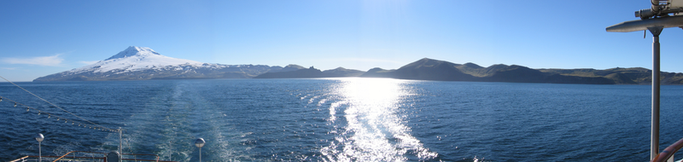

The WP player must capture the airfield, destroy all military resistance and preserve strength and ammunition.

NATO must inflict damage, ensure the local fishing fleet escapes, and once things become desperate, withdraw your forces to Reykjavík Iceland. No support should be expected, Norway is fighting for its life and the Airbase at Keflavik is still closed due to damage from a missile strike yesterday.

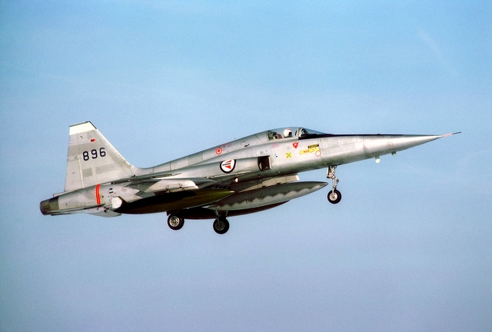

**Northern Fury #4** highlights one of many small engagements which are critical to the path of any war. Jan Mayen island defines the phrase ‘middle of nowhere’ and as such becomes as critical to the fighting in the North Atlantic as the island of Midway did in the World War Two Pacific campaign. Norway however, has not garrisoned the island in anticipation of a fight, simply a peacetime communications hub. The Soviets don’t see it this way.

