**Northern Fury #4 – A Cold and Lonely Place**

**AAR by Ilya78, Mar 2020**

"Sir, the Kiev is going down, this will be a major blow to the Soviet plans." The USS Jacksonville was awesome!!!

(Actually, the submarine didn't survive. Right after sinking the Kiev, she was found by a sonobuoy and killed with torpedoes. But her sailors were true heroes.)

So here is what have happened so far:

1. The USS Jacksonville set the course towards Jan Mayen island at cruise speed and max. depth (-984 ft). At every 15 minutes she stopped and came to 140 ft. The first enemy warships were detected as CZ contacts, so the submarine went beck to -984 ft and started creeping. As the enemy ships were coming closer, they could be heard even from this depth. An this was the moment when the fun started. The first victim was a brand new Krivak IV class frigate, which was sunk by two torpedoes. Right after launching, an enemy torpedo was detected, but it was far from the submarine, so the enemy did not know its exact position. It was easily dodged at flank speed (32 knots). After the chase a Kresta II class cruiser came into range. The Jacksonville fired four torpedoes to the ship (two were enough to sink it), and turned north at flank speed to avoid the next enemy torpedo. After dodging it, she slowed down to creep to avoid detection. And now the Kiev was well within range. All remaining torpedoes were launched from the tubes. Five hit the Kiev and I got the "scenario has concluded" message.

2. The Sidewinder-armed F-5s departed from Jan Mayen airfield for an AAW patrol. Four Yak-38 Forgers arrived from north, and my fighters could shot down only three, by using up all missiles and the ammo for their guns. They returned to the airfield for a quick turnaround. Meanwhile, the two Bullpup-armed aircrafts were launched to find the Azov by using just the good old "Mk1 Eyeball". Some minutes later Tu-16 Badger bombers arrived. Missiles from MANPADS were launched to them, and three were shot down. Only the last one could drop its bombs accurately, but those bombs destroyed everything on the airfield, including the P-3, the two F-5s and the runway. The other two F-5s could not find the Azov. They had to RTB, but the runway at Jan Mayen was damaged and Keflavik was too far away, so both aircrafts were abandoned. An-12 Cub and An-22 Cock transport planes arrived from east. The MANPADS opened fire, but these large planes did not go down after one hit. Only one was shot down, the others could drop the BMD-3s and the paratroopers.

3. The HNoMS Sklinna moved northeast, closer to the island at max. depth (-568 ft), and "laid down" to the sea floor with the engines turned off. A Tu-142 Bear maritime patrol aircraft started circling around the place, but it could not detect the submarine. Later an Echo II class SSN was detected, right when the Azov was coming into torpedo range. Two torpedoes were launched towards the Azov, both hit and the ship started sinking. The submarine launched another torpedo (just to make it safe), then turned south at 6 knots and still max. depth. Two Ka-27 Helix ASW helicopters arrived from somewhwere, equipped with active dipping sonars and magnetic anomaly detectors. They could spend only some minutes in the area (probably ran out of fuel and RTB), and the SSN had disappeared earlier, so he Norwegian submarine was still alive.

That scenario was really fun and exciting. I was literally shaking when I launched the six torpedoes towards the Kiev (and this is just a game...). I am a new Command player and I have an old laptop, which can run only smaller scenarios. I like the "Fury" series very much. Even the smaller scenarios have a very good story and they are fun to play. Thanks!

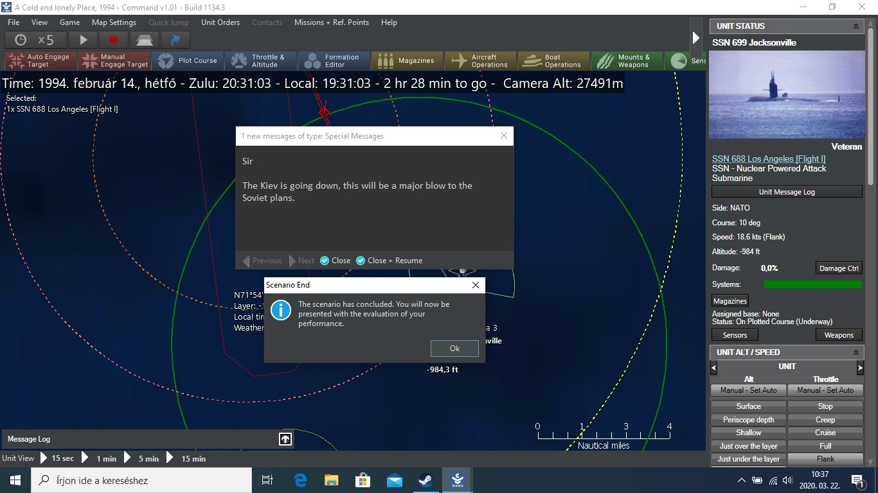

And here is what happened after sinking the Kiev:

- As I wrote before, the Jacksonville did not survive. However, four of her torpedo tubes got reloaded and all four torpedoes were launched towards the only valid contact, a DDG, which was fleeing at 35 knots. At the next moment the enemy torpedo impacted and the submarine sank. The four torpedoes could reach and sink the destroyer (a Kashin I). So the Jacksonville destroyed a frigate, a cruiser, an aircraft carrier and a destroyer. That was truly amazing! I checked the saved game with the editor and it was obvious that I had some really extreme luck with that submarine.

- The Sklinna has made it. The ASW helicopters returned (now there were three of them), but could not find her, and eventually the Bear got bored either and left the area.

- I used the HDMS Vaedderen as an ELINT platform, I just did not want to risk this nice new ship.

Thanks again, and yesterday I returned to Jan Mayen island in the "Cutting the tether" scenario, but it is another story...