**Northern Fury 5: Bardufoss Blues**

14 February, 1994, 1200 Zulu, 1300 Local

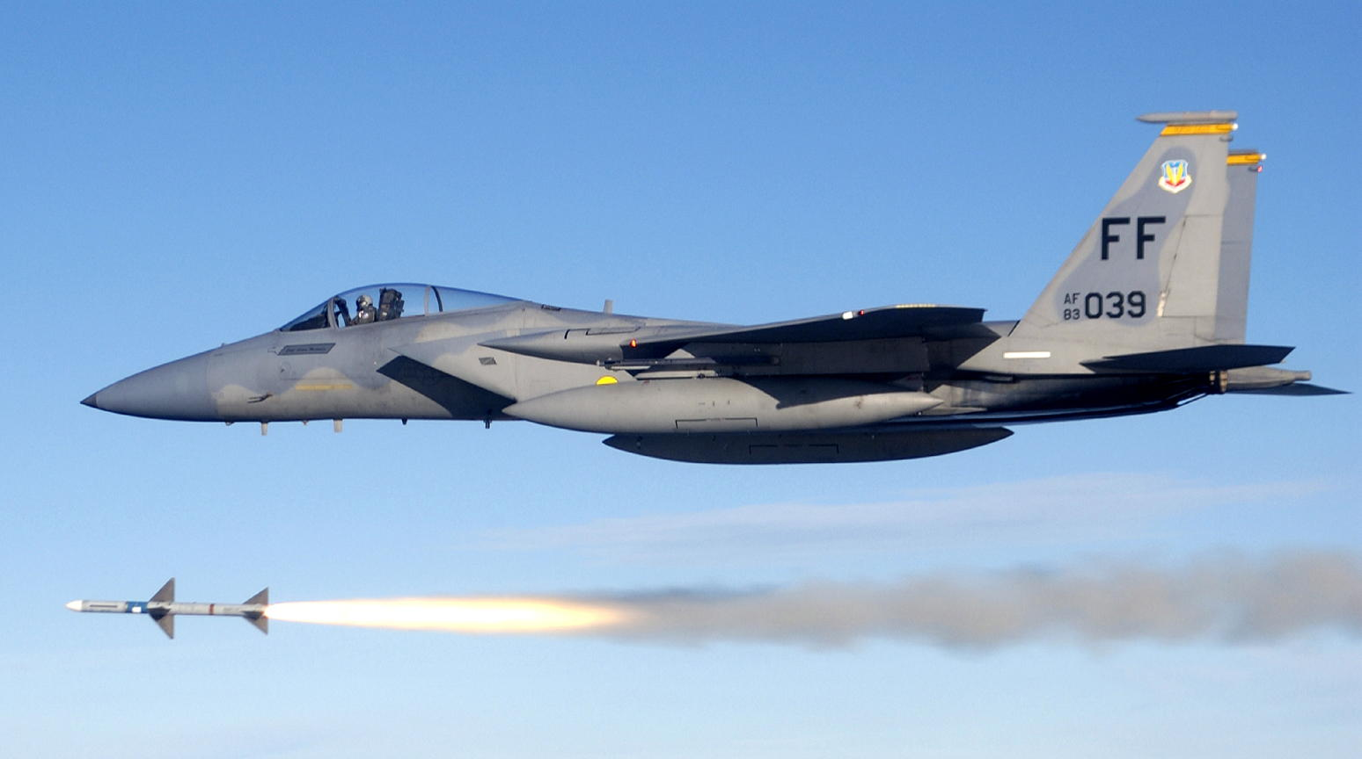

Approaching noon on day two of a new global war. As commander of Allied Forces North, you are re-grouping surviving units and bringing in new reinforcements as fast as you can get them. The past 12 hours has been relatively quiet. Once the Soviet airdrop on Banak was complete, the CAP up at Bardufoss was only encountering 15-20 Soviet sorties an hour. Jamming continues to be heavy and very effective, you can only assume that Soviet ELINT is picking up most of your transmissions. There has been very heavy transport and single engine traffic into Banak and Kirk

Your available aircraft are severely depleted, your pilots are tired, your ground crews are exhausted, and your stock of AAW missiles is draining rapidly. You grudgingly consider a further withdraw of forces to the South. The situation on land is stable, Soviet ground forces have linked up with the airborne forces at Banak but have not proceeded much beyond that. The Maritime situation is improving marginally, the Norwegian Navy has put to sea and STANAVFORLANT is moving to assist.

The Norwegian parliament was hit by a truck bomb yesterday, both the Prime Minister and the King were killed. The Minister of Foreign Affairs is now the head of state; the government; however, is in chaos. Decisions and guidance are nonexistent. Orders and coordination is coming from SHAPE in Belgium and the NATO Command structure is working (much to everyone's surprise), but is focused on the Central front.  Reinforcements are also coming – but slowly.

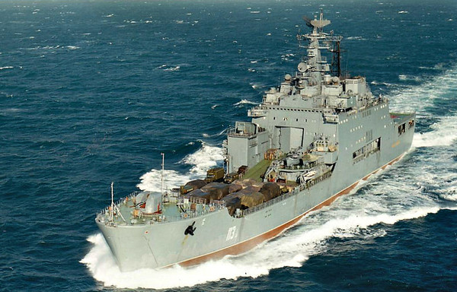

**Northern Fury #5** shows NATOs defences starting to rally, recover and recoup initial losses. The Soviets however have several surprises in store and are no where near finished with their offensive campaign. In addition to the major air battle over Bardufoss you will need to pay close attention to what is happening in the Norwegian Sea.

