**Northern Fury 6 - Trondheim Express**

14 February 1994, 1800 Zulu, 1900 Local

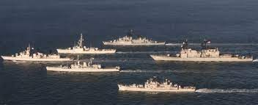

Day two of a new global war, and it has already gone badly. You are commander of Allied Forces North, and the situation went from being bad yesterday to disastrous this morning! You staff have focused on re-grouping your surviving units and bringing in new reinforcements as fast as possible. A major Soviet push this morning has forced your air units South, effectively closing Bardufoss. Tromso, Evenes is still open but barely. Your heavily depleted air units have scrambled back to Bodo where 3 Norwegian and 1 Dutch F-16 Squadrons with the F-15s of the US 493rd FS are attempting to hold back hundreds of Soviet A/C. Jamming continues to be heavy and very effective, you can also assume that Soviet ELINT is picking up most transmissions. Both Banak and Kirkens airfields were in operation against us this morning.

Your available aircraft are severely depleted, your pilots are tired, your ground crews are exhausted, and your stock of AAW missiles is draining rapidly. You grudgingly consider a further withdraw of forces South to Orland and Vaernes.  The one bright spot is the arrival of a British Jaguar and 2 USAF F-16 and Squadrons. The situation on land is equally bad, an airmobile operation NE of Bardufoss this morning seized the passes and dislocated the defenders there - Bardufoss will fall in the next few hours, it is already under artillery fire. The Maritime situation is improving marginally, the Norwegian Navy has put to sea and STANAVFORLANT is moving to assist.

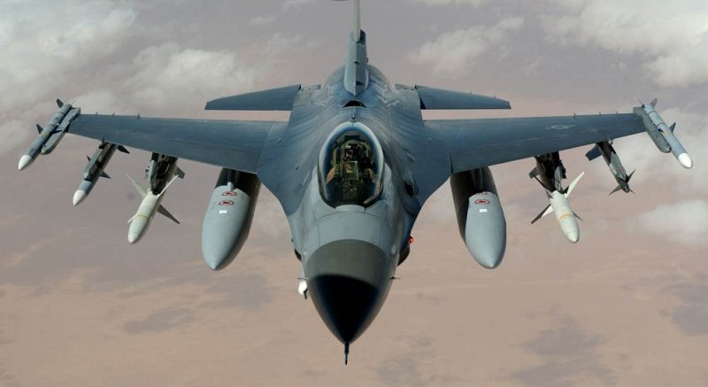

**Northern Fury #6** is closely linked with scenario 5 and is a continuation of the same fight. New actors have entered the fray on the NATO side in the form of the Standing Naval Force Atlantic (STANAVFORLANT) and several aircraft squadrons.

Although the tough fight continues, NATO is finally getting the resources it needs and the Soviets are reaching the end of their effective range, at least until they can establish forward bases.

