**Northern Fury 7 - Keflavik Capers**

15 February 1994, 1500 Zulu, 1200 Local

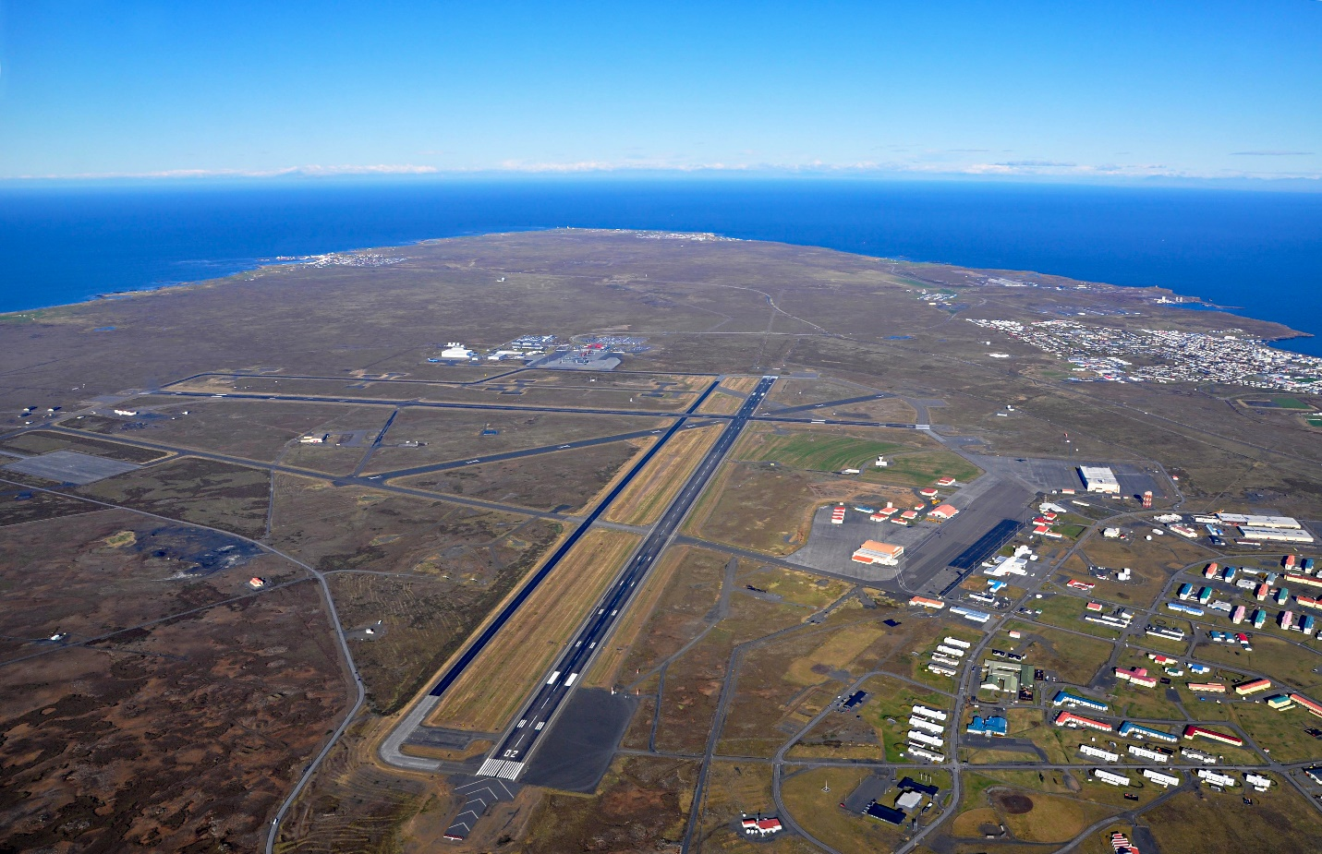

It is early afternoon and you as the **Commander US forces Iceland** at Keflavik Air Station, are receiving ominous reports!

War started Sunday and Keflavik was one of the first targets, a surprise missile attack which closed the two main runways and destroyed seven aircraft on the ground - and only 5 missiles got through our defences! Last night Jan Mayen Island, 500nm NE of here, was captured in a quick and dirty airborne assault. This morning, Trondheim Norway was under assault from the sea. STANAVFORLANT was in heavy contact, and that situation is unresolved.

The enemy needs to open a portion of the GIUK gap to allow his subs, long range aviation and surface units access to the North Atlantic. The move on Trondheim may mean that they will go for the Southern gap between Scotland and Iceland, putting you in a supporting role with the weight of the attack landing on the Brits. If not, it could get very messy here in the next 24 hours or so. You need time to reinforce and get the base onto a real war-footing.

The GIUK (Greenland – Iceland – United Kingdom) Gap is the 1000-mile-wide entrance into the North Atlantic; if the Soviets control this area, NATO reinforcement and supply convoys to Europe are threatened. In peacetime a string of radars and SOSUS network provide early warning, backed up by fighter and maritime patrol aircraft in Keflavik Iceland and bases Scotland. In reality this serves as nothing more than a tripwire to allow NATO forces to rapidly deploy and reinforce the outpost of Keflavik.

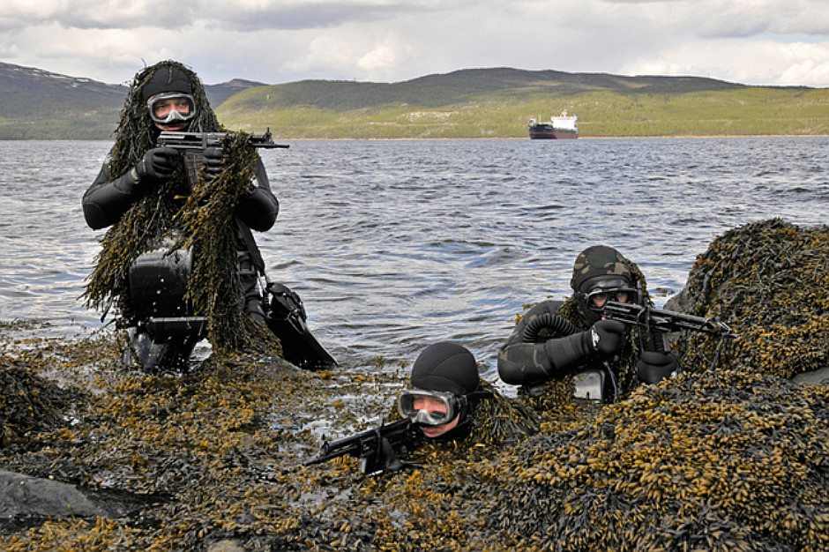

**Northern Fury #7** is closely linked to both the Trondheim battle (NF 6) and the fight for Jan Mayen (NF 4), as well as the next series in the campaign (NF 9). The Soviets are desperate to gain a foothold on the GIUK gap and bypass NATO’s stranglehold on the Atlantic. They can do this in one of several ways, but which way – Iceland, Southern Norway or the islands in between, will be successful?

