**Northern Fury 8 - Plug the Gap**

16 February 1994, 0001 Zulu, 0001 Local

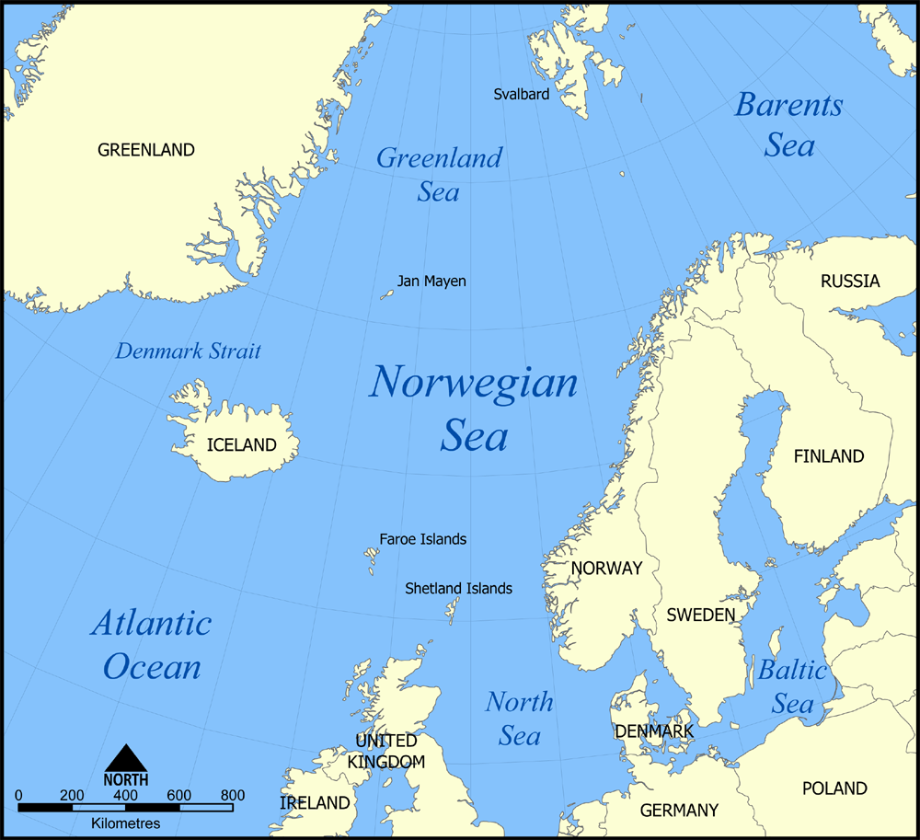

Steaming North as the fourth day of a new global war opens, you are in **Command of the HMS Invincible Task Group** and are heading into harm’s way!

Dawn yesterday saw an amphibious assault around Trondheim. It looks like the Norwegians with the able help of 3 Royal Marine Commando Bde are holding, but pressure from the north is forcing the Norwegian Army to collapse southwards. Narvik fell late yesterday afternoon. STANAVFORLANT is withdrawing in tatters with the remaining surface units of the Norwegian fleet – they are out of it for a bit.

Reports from Iceland are vague, but it appears that Spetsnaz forces have captured several out-ports and key radar installations have been knocked out. The Americans are looking after that sector, but you are keen to understand what is going on there as it has a direct bearing on your command. You expect the hammer to fall either in Iceland or here at the UK end of the GIUK Gap.

The GIUK (Greenland – Iceland – United Kingdom) Gap is the 1000-mile-wide entrance into the North Atlantic; if the Soviets control this area, NATO reinforcement and supply convoys to Europe are threatened. In peacetime a string of radars and SOSUS network provide early warning, backed up by fighter and maritime patrol aircraft in Keflavik Iceland and bases in Scotland. In reality this serves as nothing more than a tripwire to allow NATO forces to steam north and ‘Plug the Gap’.

**Northern Fury #8** The central portion of the GIUK gap is perhaps the most vulnerable, but also difficult to attack. The Soviets would not likely wish to invade Scotland proper as that would entail a large-scale land-based fight with the UK and reinforcements direct from the US. An unwanted distraction which would open up too many vulnerabilities. Instead, there are several island chains which could achieve the desired result of opening up access to the Atlantic. Key among these archipelagos is the Faroe Islands which are Danish, and to a lesser extent, and more dangerous to assault are the British Shetland islands, the outer Hebrides or even the Orkneys.

NATO is struggling to pin down where the Soviets will make their main push. Being strong everywhere is difficult but divining where to put the weight of defensive effort is confounded by deception, misinformation and feints.

