**Northern Fury 9 - Hold the Line!**

17 Feb 1994, 0800 Zulu, 0600 Local

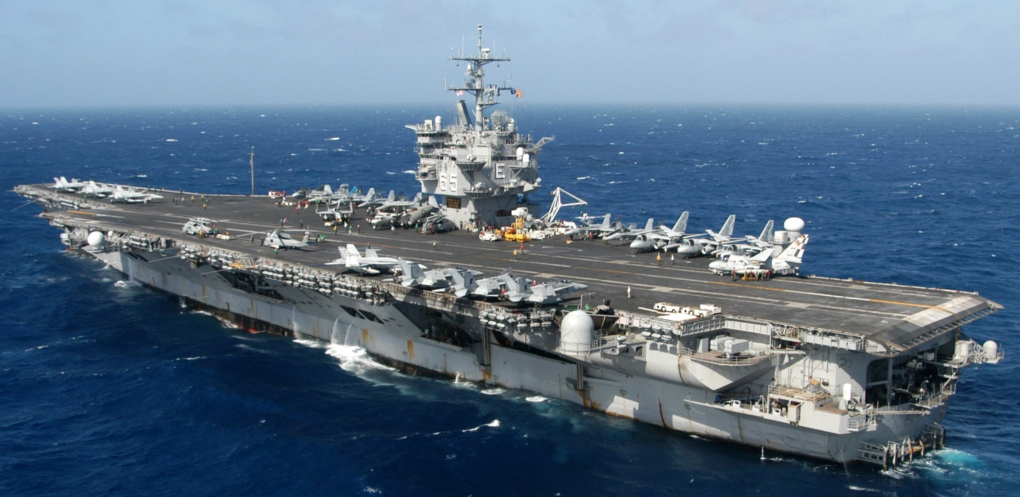

**You are the commander of the USS *Enterprise* CVBG, (CVN-65)**. Due to heightened tensions, your refit/re-fueling was rushed through and completed 8 months ahead of schedule. On the 12th of Feb, while completing your workup trials off of Puerto Rico, you were sent a FLASH message to precede north at best possible speed. In your Task Group are the USS *Anzio* CG 68, a brand-new Ticonderoga class cruiser, another Tico, CG 63 *Cowpens* and the venerable Leahy class cruiser CG-17 *Yarnell*. Adding potency to the escort, two refurbished Spruance class DD’s, the *Thorne* and *O’Bannon* have just completed workups, both with the new Vertical Launch System (VLS) providing a very robust missile capability. Two FFG’s the *Curts* and *Simpson* round out the TG. Your air group is Carrier Air Wing 6, and it’s a bit of a mixed bag, you have some of the oldest aircraft in the fleet (A6-E’s) and 6 of the very newest F/A-18C capable of using the AIM-120 AMRAAM missiles, which proved very effective during a training run through.

The journey north was full of news, as the war developed your training became very serious. At dawn on the 15th as the TG passed Bermuda it went into a Communications Lockdown and later that day met up with a replenishment group. By dawn yesterday you were topped up with all the supplies and ammunition needed. AOE 3 *Seattle* remained with the TG, although its slower speed is a hindrance you cannot afford the escorts to break her away, she needs to be handy for emergency re-supply.

Just before midnight last night you received a warning order from CINCLANT informing you of some late developments – including the fall of Iceland. Your orders were to position the TG northeast of Newfoundland and prepare for heavy engagement, several land based squadrons were placed under your Operational Control and at 0200 this morning you held a communications check with 5 submarines that are being coordinated by you.

A few minutes ago, you were called to your communications room to receive orders.

Good Shooting and Godspeed Admiral!

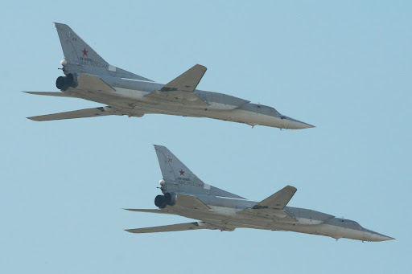

**Northern Fury #9** every campaign has a turning point, if all goes well this scenario should be that point for NATO. The pre-war plan was never to put a single carrier up against the Soviet onslaught, but realities have forced the hand of Commander 2nd US Fleet, and until forces can assemble – the Big-E (USS Enterprise) is all that is available.

Prepare for a fight.

