**Northern Fury 13 – Cutting the Tether**

21 Feb 94, 2000 Zulu, 1900 Local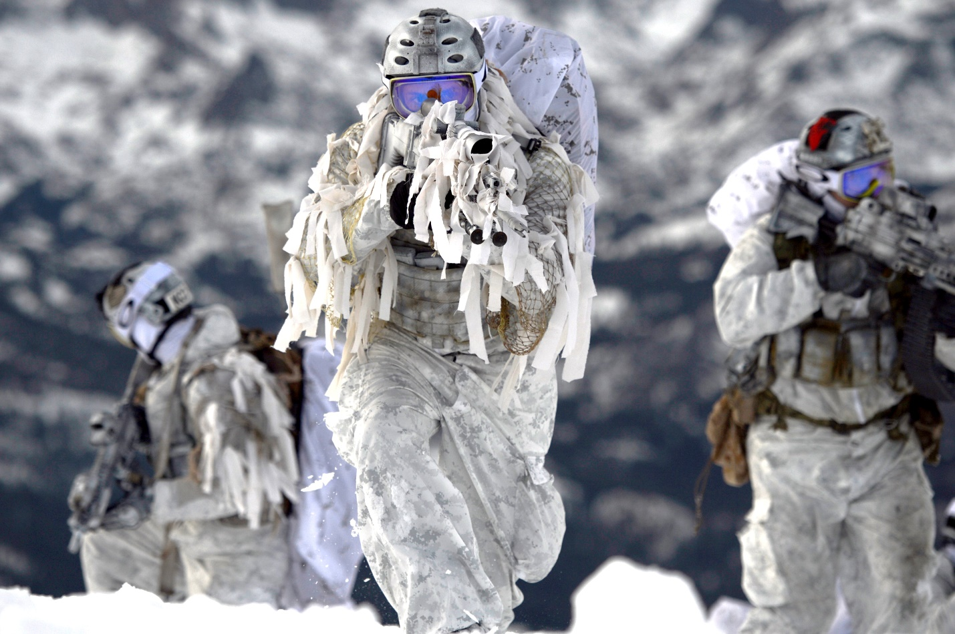

This is a small but critical scenario in the battle to isolate Soviet forces on Iceland. Since taking the island of Jan Mayen in the first hours of the war, the desolate spot on the Greenland Sea has become a critical link in Iceland’s supply chain, a long and arduous link back to the Kola Peninsula. Your job in this scenario is to cut that tether.

**Northern Fury #13** is a small Special Forces operation with fairly conventional opposition. If approached correctly there should be little difficulty, however if things go wrong – they will go very wrong.

