**Northern Fury 14 – Here Comes the Cavalry**

21 February 1994, 1800 Zulu, 1600 Local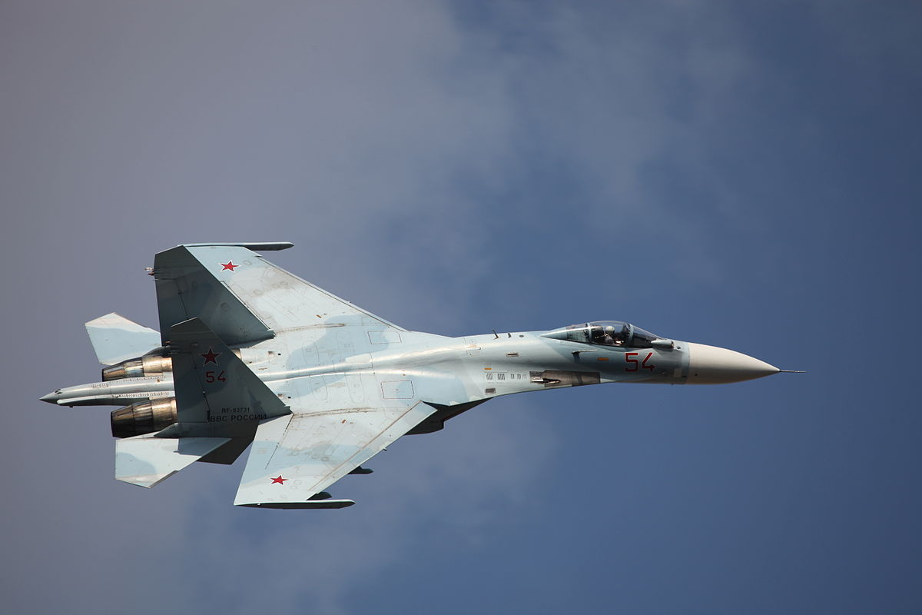

The US 2nd Fleet is now ready for its first counterattack. The 1st phase has the USS Eisenhower and the USS Carl Vinson CVBGs strike at Soviet forces around Iceland.

In order to neutralize the significant Soviet forces on Iceland your task is to move north and establish local air superiority over the Keflavik peninsula as a precursor to a large USAF strike tomorrow night. You have 28 hours to destroy Soviet Air Defences over Iceland. Detailed SEAD and Strike tasks will be the Air Forces job, but you need to clean the airspace to make that possible. You know that there are formidable air defences both on and over Iceland so this will not be an easy task.

**Northern Fury #14** is the first of five scenarios where NATO is focused on reducing the defences of Iceland. During this first attack, the primary opposition will be Soviet fighters, and it is a formidable defence.

