**Northern Fury 15 – Stab in the Dark**

21 Feb 94, 1000 Zulu, 0800 Local

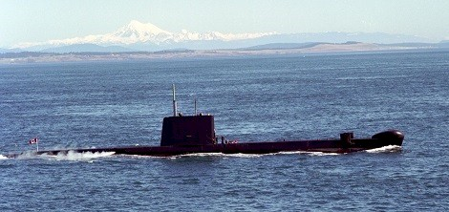

This is a small and straight forward scenario. Your task is simple, as the Captain of the Canadian Submarine HMCS Onondaga, infiltrate Soviet ASW defences north of Reykjavik and insert a Special Forces team comprising of 4 Canadian JTF2 (Joint Task Force 2) and 4 British SBS (Special Boat Service) operatives. However, you may find that in war – nothing is simple.

**Northern Fury #15** provides an opportunity for stealth and patience. Although the Soviet defences are dispersed, they are on heightened alert and will not be surprised that Special Forces teams will be coming ashore.

