**Northern Fury 16 - Sub Surge**

22 Feb 94, 2100 Zulu, 2100 Local 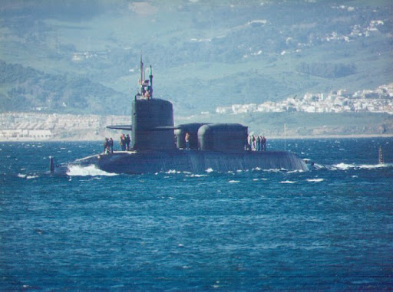

This is a medium size scenario focusing on pushing NATO submarines and some unique capabilities through the Greenland Sea to the very edge of the Barents Sea and the Arctic Ocean. The Soviets consider this area home waters, and protect the Barents Sea, one of their critical ‘Bastions’, vigorously. In addition to standard sub vs. sub action you will be required to complete several special missions while the Soviets hunt for you plentiful and alert air, surface and sub surface forces.

**Northern Fury #16** has the player conducting a wide variety of submarine missions from attack patrols, to inserting Special Forces, to establishing electronic listening stations and tapping into undersea cables. The main effort of this operation is to further isolate Soviet forces on Iceland from their supply base in the Kola Peninsula, but much more is going on. It is not surprising that the Soviets will try very hard to prevent this from occurring.

