**Northern Fury 17 - Stab in the Dark**

 22 Feb 94, 2100 Zulu, 2000 Local

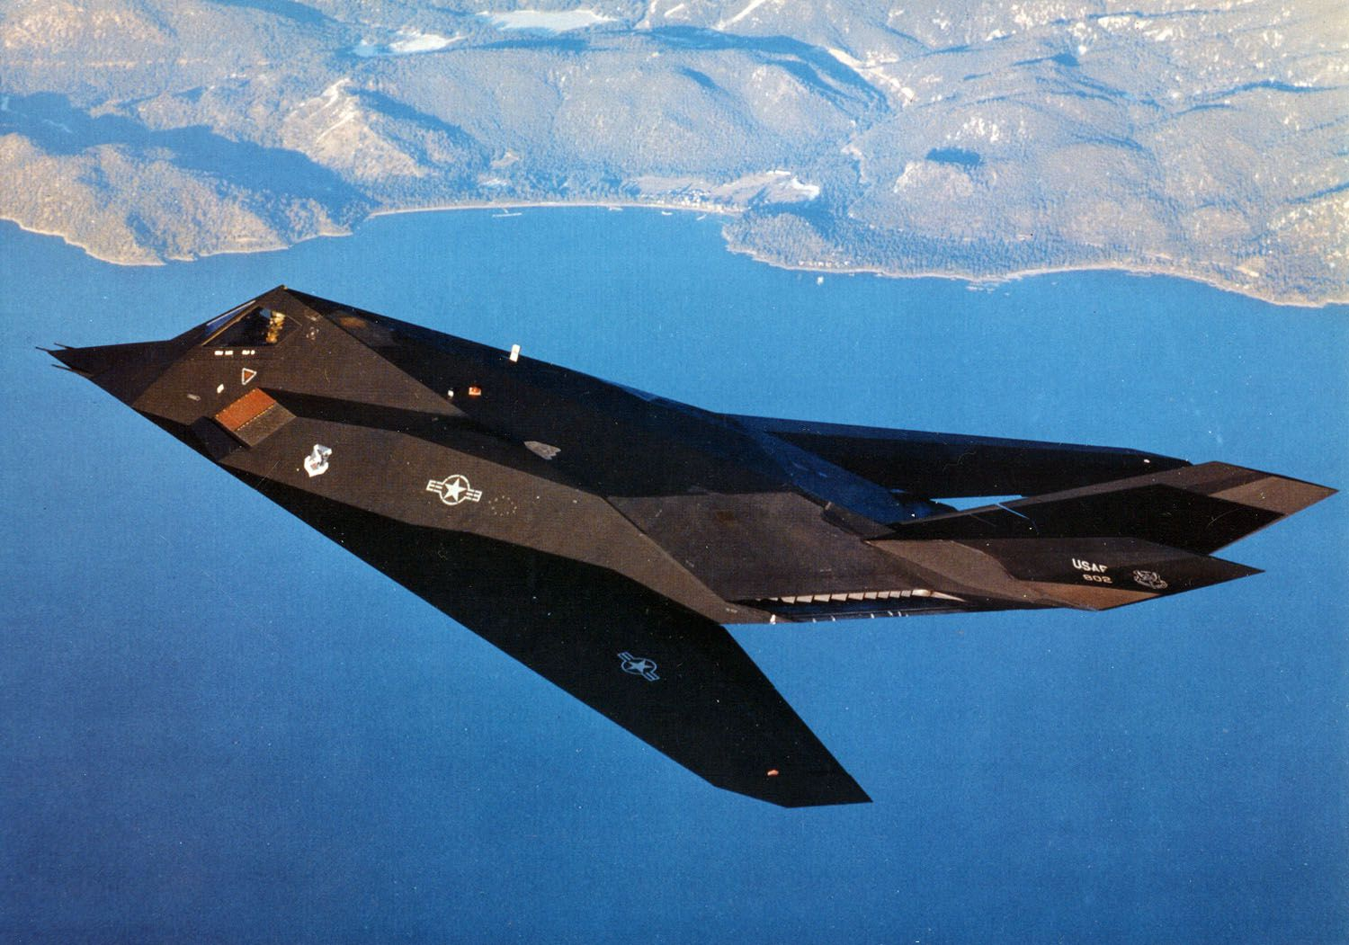

This is a very small and straight forward scenario which provides an interesting change from the massive operations that are ongoing. 42 hours ago, your Special Forces team comprising of 4 Canadian JTF2 (Joint Task Force 2) and 4 British SBS (Special Boat Service) operatives arrived in Iceland. Now it’s time to earn your paycheck.

**Northern Fury #17** is a very short exercise in non-traditional targeting. The assets in play are also quite non-traditional for 1994, Special Operations teams and F-117 stealth fighters.

