**Northern Fury 18 - Ant Eaters Revenge**

 22 February 1994, 1600 Zulu, 1400 Local

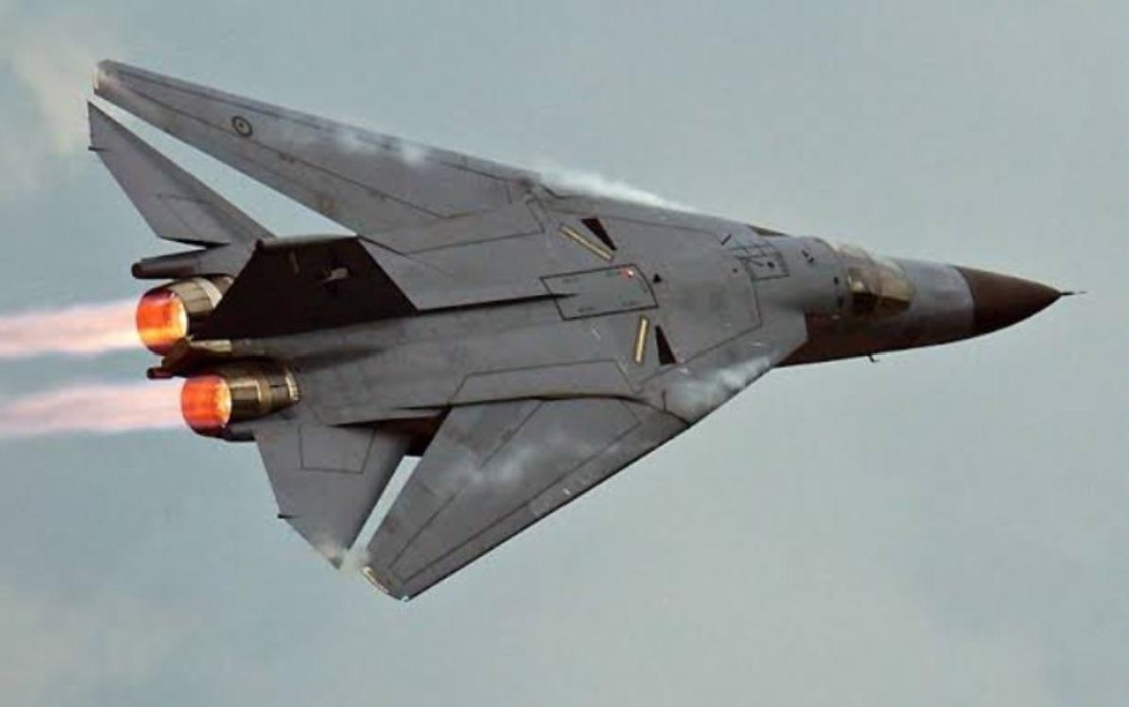

You are tasked with conducting a decisive airstrike with the **27th Tactical Fighter Wing (TFW) reinforced**, while transiting your forces to England. The 27th TFW consists of 3 squadrons of F-111 and a supporting squadron of EF-111s ECM aircraft, for this strike the wing has been reinforced by a squadron each of F-15C, F-15E, F-16CJ, F-4G Wild Weasel, F-117 Nighthawk and other supporting forces.

**Northern Fury #18** is a very difficult scenario. The F-111 which is your major strike asset is an aircraft that is between generations; far more capable than the Vietnam era aircraft it replaced, but far less capable of modern 4th generation aircraft. Although it pioneered many new and cutting-edge technologies when it was delivered in the 1970s, by the 1990s these had long been superseded. In most situations however, the Aardvark was still a very capable bomber, unfortunately the defences in place on Iceland do not represent most situations.

