**Northern Fury 19 - Decapitation**

 23 February 1994, 0400 Zulu, 0300 Local

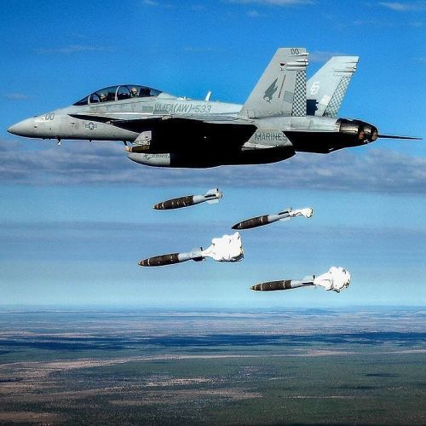

With two Carrier Battle Groups, you are tasked with conducting precision strikes to eliminate HQ and C2 facilities on Iceland. After two days of whittling down the defending fighters on Iceland, the USAF struck last night to eliminate the Surface to Air Missile (SAM) defences. Now it is time to take out the Command and Communications elements.

**Northern Fury #19** provides a chance for some precision bombing and detailed strike planning. In addition to HQ, you are tasked with destroying logistics, infrastructure and airbases, the target list is quite long. Unfortunately, the strikes eliminate air defences were not completely successful.

