**Northern Fury 20 -** **BUFF Stampede**

23 February 1994, 1800 Zulu, 1600 Local

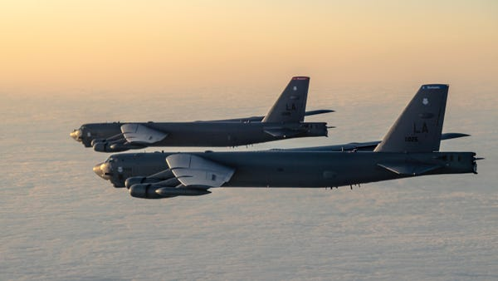

You are to conduct a short, sharp bomb run of key facilities remaining on Iceland while transiting the **2nd Bomber Wing** to bases in England. Your bomber wing is comprised of 3 Squadrons of B-52’s and has been augmented by a Squadron each of B-1’s, EF-111. F-16 Blk 40 and several squadrons of tankers. As well as support from elements of 2nd Marine Air Group (2MAG), and a U-2, the ‘***Spirit of Missouri***' one of 8 operational B-2’s will make that types combat debut *(in the Northern Fury World).*

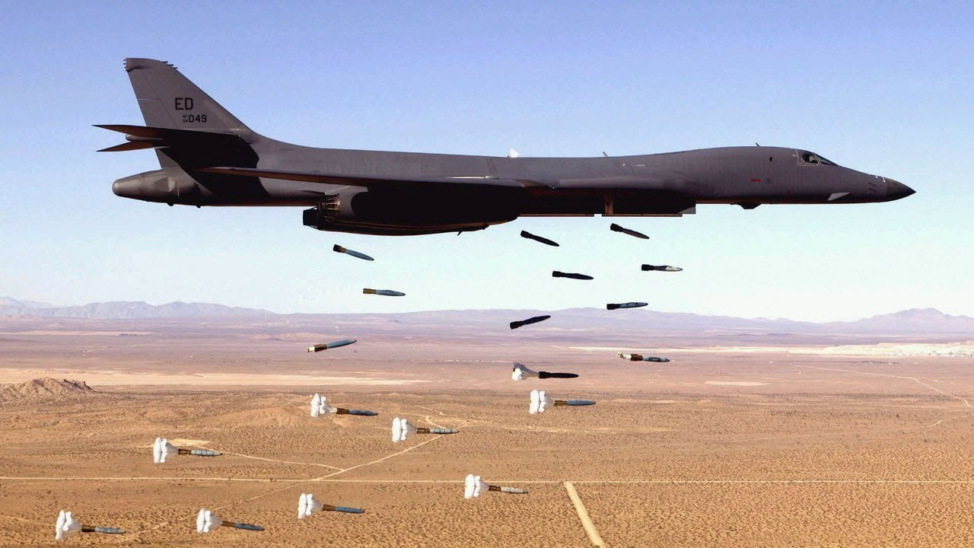

**Northern Fury #20** gives the USAF a second strike on targets it missed the previous night, and they’ve brought out the big guns. Over 20 BUFFs (Big Ugly Fat Fellas – B-52s), a dozen BONEs (B-1s) and a B-2 bomber are tasked on this strike.

