**Northern Fury 21 - Sweep Up**

24 February 1994, 0600 Zulu, 0400 Local

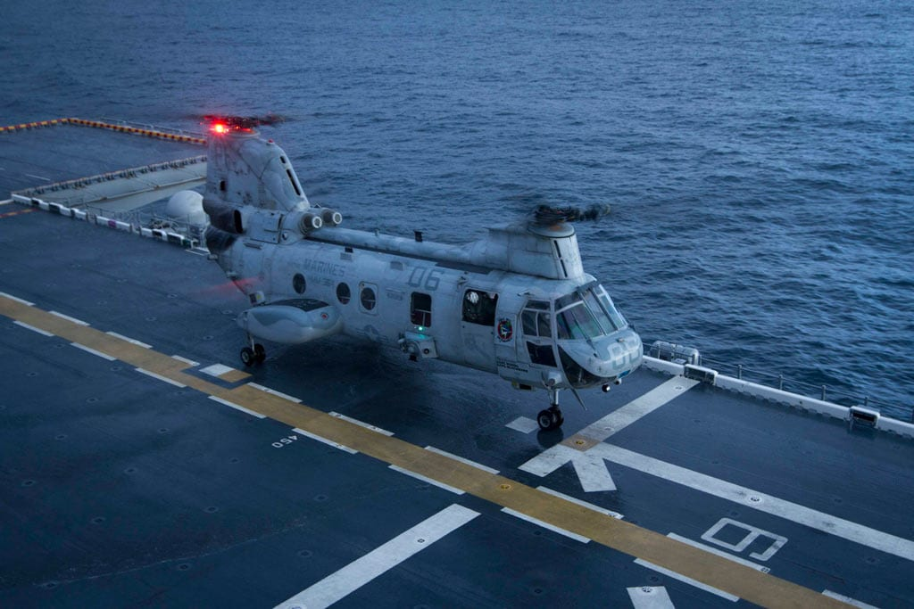

The US 2nd Fleet is now entering the final phase of its first major counter-attack. A ceaseless combination of bomber and carrier borne attacks over the past 60 hours has reduced the defences on Iceland significantly! Now all that is left is the task of sweeping up the last few targets and preparing the ground for the amphibious assault by the Marines tomorrow. If you have learned anything this past week; however, nothing is simple.

You have a very busy day ahead of you which will cause your forces to split – never a good thing while a competent and resourceful enemy waits for opportunities to inflict delay and damage. Your main tasks are to: Destroy any targets that have escaped prosecution so far. Also to destroy 30-40 bridges dividing the island in thirds, ensuring that the other, larger bridges are undamaged. Marshal, escort, insert and support a Marine Bn as it conducts a Coup de Main operation. Sweep the Denmark Straights of Soviet submarines. Destroy facilities on Jan Mayan Island. And finally to keep the Soviets at bay, and do so with minimal casualties. Enjoy!

**Northern Fury #21** is an extremely busy scenario. The player has many tasks and many conflicting priorities, also new and unexpected events will pop up to keep things interesting. The Soviet defences are now largely disrupted – but not destroyed.

