**Northern Fury 22 - Vagar Vengeance**

25 February 1994, 1500 Zulu, 1500 Local

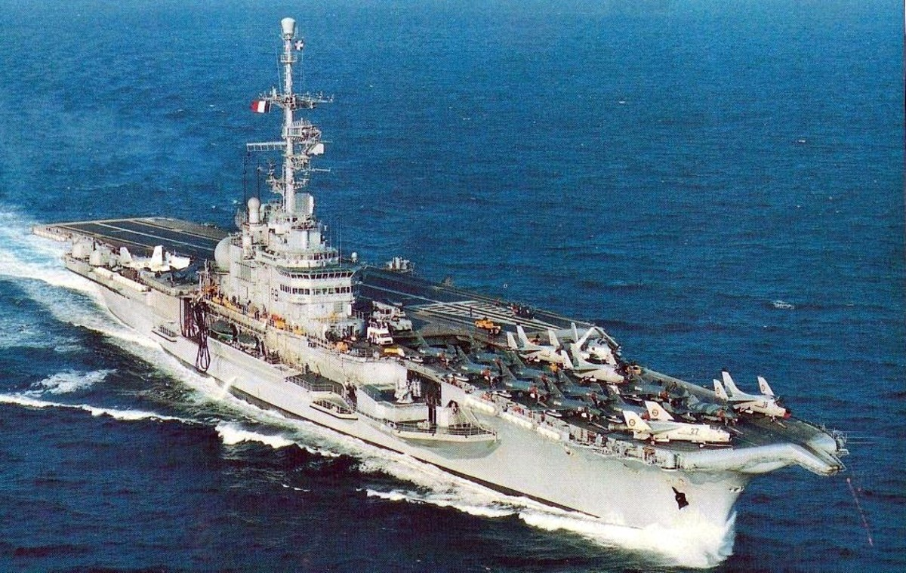

Strike Fleet Atlantic (STRIKFLTLANT) is now conducting its first major counterattack. The 1st phase was the softening up of Soviet defences on Iceland which has taken place over the past several days. Now as a preliminary move to the retaking of Iceland, the Faroe Island chain must be secured with a primary focus of the Vagar island airport.

You are **Commander of TG Invincible and supported by the French carrier Clemenceau**, surface, subsurface and amphibious forces as well as land based air elements. Your task is to unhinge the Soviet defences, protect reinforcing airborne operations and clear the defenders out of the Faroe Islands, all while protecting civilian infrastructure and preserving your force. The Soviets, however, have other ideas.

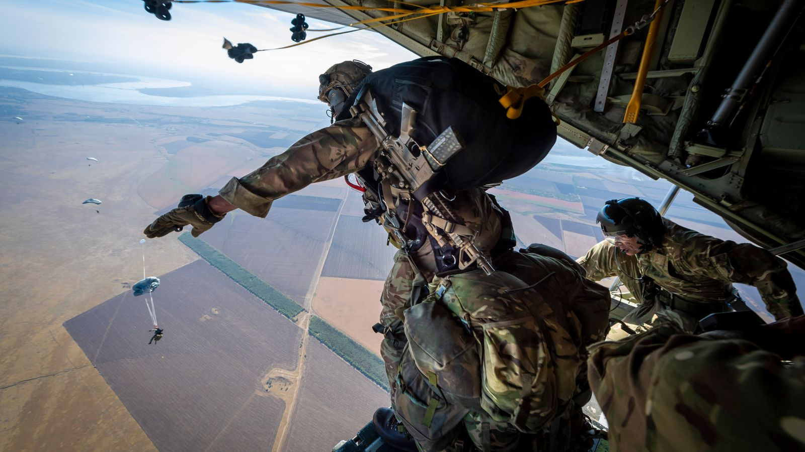

**Northern Fury #22** is an interesting scenario using British and French assets to conduct an amphibious and airborne operation. Soviet defences are well prepared but much less potent than those on Iceland, however the assaulting forces are also much less numerous.

