**Northern Fury 23 - Swift, Silent, and Deadly**

25 February 1994, 1800 Zulu, 1600 Local

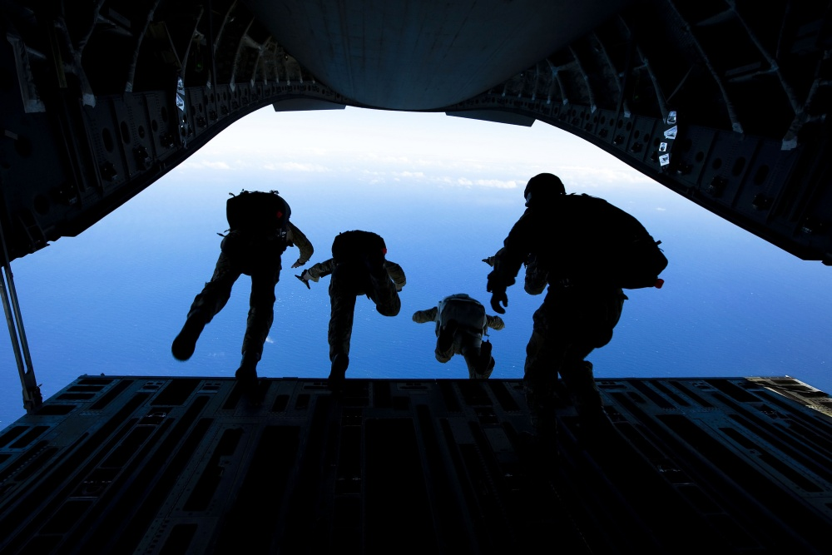

You are the **CO of the Force Recon Battalion of 2nd MEF** (Marine Expeditionary Force) and you will be leading a risky para drop onto Iceland tonight. If all goes well, you will link up with the landing elements of the two assaulting Marine Regiments by this time tomorrow. A quick scan of the Drop Zone names however, reminds you that on operations such as these things don’t always go right!

**Northern Fury #23** is a medium sized scenario which puts the player in a difficult position. The defences are not fully neutralized yet but there is work to be done if the landings are to succeed (next scenario). Should the player focus on stealth and risk being put into a very bad position, or should s/he go in all guns blazing to finish of the bad guys?

