**Northern Fury 24 - Battle Wagons to War!**

26 February 1994, 0100 Zulu, 0000 Local

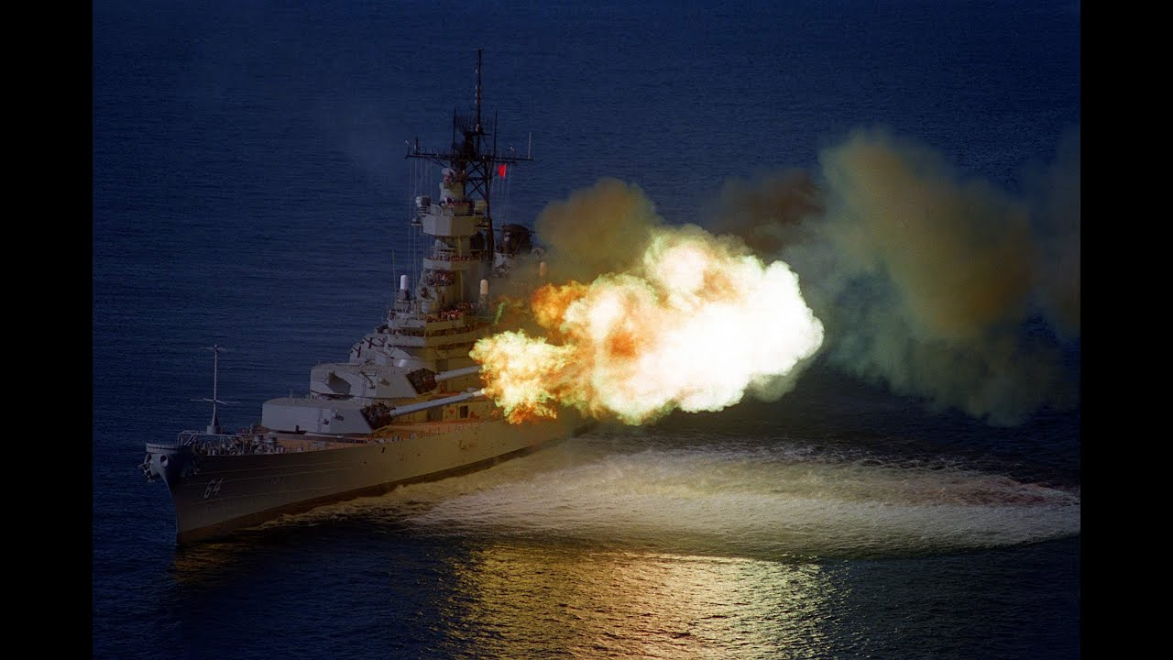

A ceaseless combination of bomber and carrier borne attacks over the past 72 hours has reduced the defences on Iceland significantly! The Marine Force Recon element is going in right now and a Battalion landing team seized the airport at Vestmannaeyjar late yesterday. Your job is to soften up any defences and support the buildup of the new airbase.

As commander of the Covering Force for the Amphibious assault which arrives in a few hours, you command two Battleship Task Groups, and for tonight’s operation you are also protecting the advance element of the Amphibious Task Force, LPD Shreveport. You have a busy night ahead of you, targets to shoot at, marines to deliver, supplies to position and bases to prepare – not many in your force will sleep tonight!

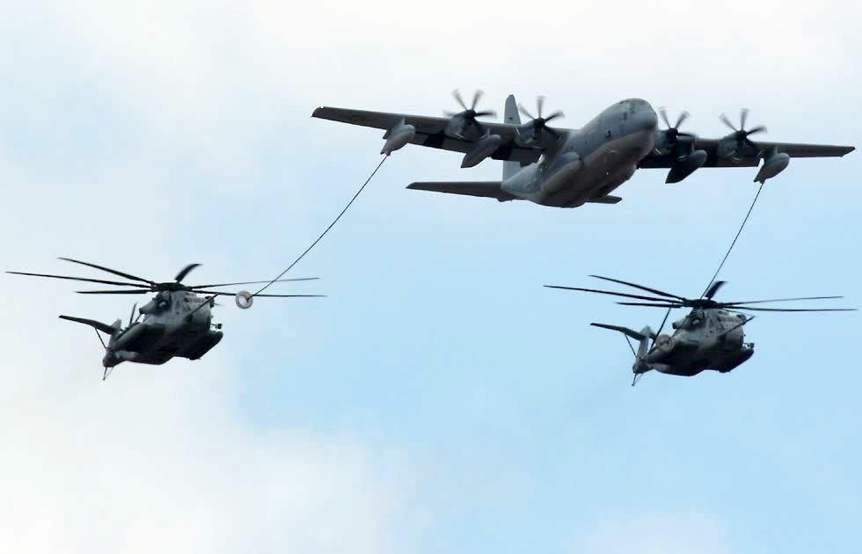

**Northern Fury #24** puts the player in a preparatory role, major amphibious assaults don’t just happen, there is a lot of advance activity that needs to occur, and that is what this scenario is all about. The main reason the Battalion Landing Team went in yesterday was to secure the airport at Vestmannaeyjar, now it must be improved and supplied so helicopters and harriers can operate and support the landing. Also, the Force Recon elements who are jumping onto the island will need support and several other areas will need to be watched. Let’s not forget about the enemy though – he is sure to try something to foil the overall plan.

