**Northern Fury 25 Jar Heads on Ice!**

26 February 1994, 0800 Zulu, 0600 Local

Earlier this morning the Battleships were unleashed to further reduce the defenders combat power and Marine Force Recon element went in to secure key areas. Late yesterday a Battalion landing team (1st BN 6th Marines) seized the airport at Vestmannaeyjar, which has been built up and is ready to receive F/A-18s. The moment is finally here – your job is to conduct simultaneous amphibious landing of 6th and 8th Regimental Combat Teams (RCT-6 and RCT-8) of the 2nd Marine Expeditionary Force (II MEF).

As Commander 2nd Fleet you have moved north in your Command ship (LCC 20 Mount Whitney) to oversee this operation. Under your direct command are the majority of the Amphibious forces in the Atlantic Fleet, the two Battleships which saw action earlier, the USS Theodore Roosevelt CVBG, and several independent elements. Providing a distant screen for this operation (and not in this scenario) are the USS Carl Vinson, USS Eisenhower, and HMS Invincible CVBGs. Speed is of the essence, all of these High Value Units (HVU) concentrated in a small area are a magnet for trouble.

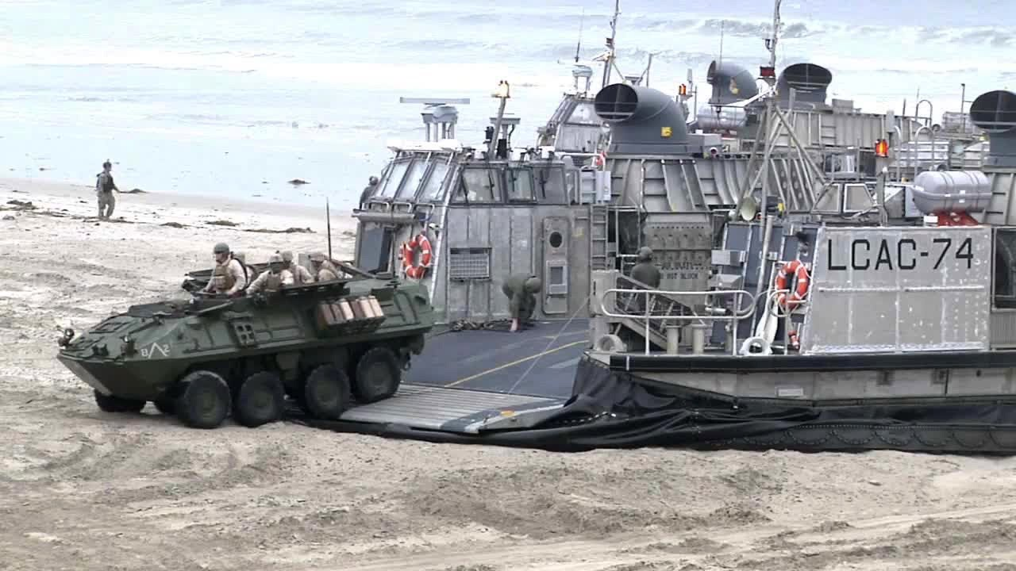 **Northern Fury #25** is a large and diverse scenario where the player will need to juggle conflicting requirements in at least two areas. The player has many unique units and overwhelming resources at their disposal but will have difficulty making sure that the right element is in the right place with the right equipment at the right time. Not an easy task.

