**Northern Fury 26 Land of Fire & Ice!**

28 February 1994, 1700 Zulu, 1600 Local

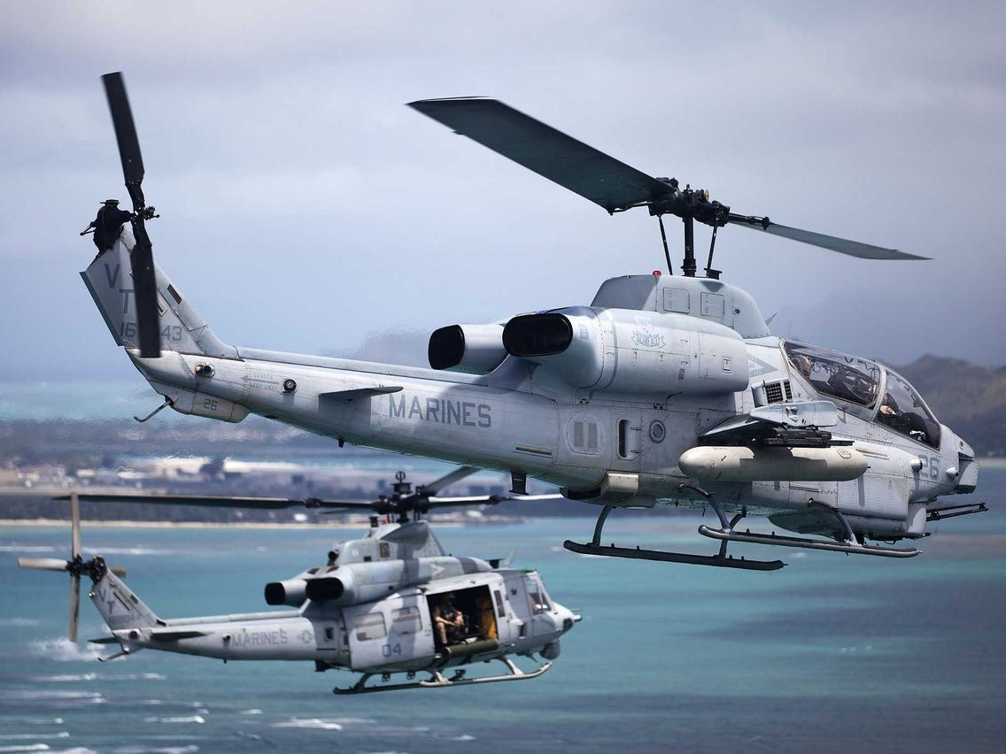

2nd Marine Expeditionary Force (II MEF) executed an amphibious and Heli-borne landing on Iceland two days ago at dawn on the 26th of February with two Regimental Landing Teams (RLT), 6th Marine RLT along the south coast and 8th Marine RLT on the west coast. The battle is progressing well, air and sea superiority has allowed the many US ‘Combat Multipliers’ to play, giving the marines a significant advantage.

The Soviet 76th Guards Airborne Division, subjected to days of air and naval bombardment has ceased to exist as a fighting division but its regiments maintain some cohesion even after significant casualties. Split into two parts, the remnants of two regiments are forming a last-ditch defence in the area of Reykjavik and Keflavik while in the east of the island the 234th Air Assault Regiment is collecting as many stragglers and heavy weapons systems as it can to defend the rugged areas east of the American landings.

As Commander of the 6th Marine RLT, you are to execute a contingency operation to disrupt the 234th Regiments operations along the north coast of Iceland.

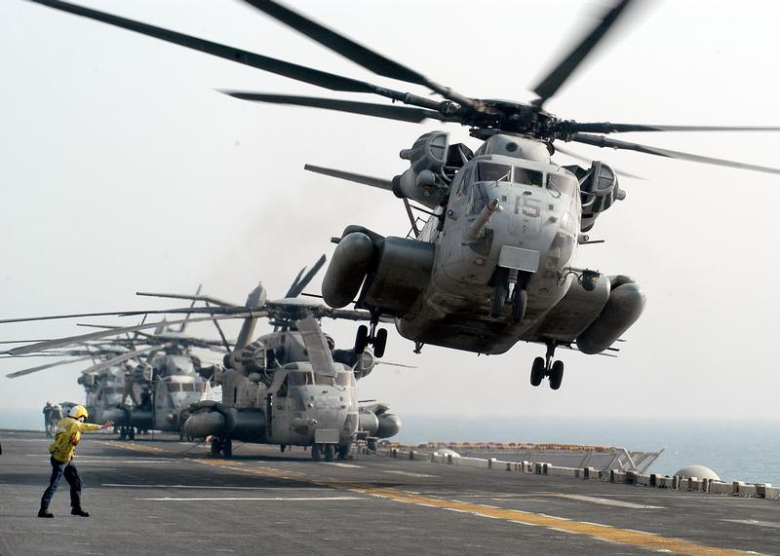

**Northern Fury #26** represents an opportunity in a major operation where a small unit action might turn the tide. The Battalion Landing Team (BLT) which conducted the coup de-main on the island of Vestmannaeyjabær is now the MEF reserve force and has been tasked to seizing that opportunity. But with every opportunity, there is risk.

