**Northern Fury 27 - Out on a Limb**

 28 Feb 1994, 0100 Zulu, 0100 Local

**Global Situation**

The new global war between the Soviet Bloc and the West has been raging for two weeks now, NATO is now on the offensive, but the Warsaw Pact is far from defeated and is still resisting fiercely on Iceland and threatening offensive operations in Norway. The ground war in Europe continues to be brutal and deadly, Berlin has fallen but the Germans continue to govern from the old West German facilities in Bonn. North American ‘REFORGER’ reinforcements continue to arrive in Europe. The immediate reinforcement to Europe of the 24th Infantry Division (24 ID) and 3rd Armored Cavalry Regiment in the first week of the war was quickly followed by the deployment of III US Corps complete (1 ID, 1 Cav D, 2 AD, 4 ID, 5 ID & Corps Troops) which has largely deployed and is forming in Germany. Meanwhile, the 101st Air Assault Division has deployed to Egypt to stabilize the situation there and the 82nd Airborne Division, which up to now has been the US Strategic Reserve, will soon deploy to Sicily as the Operational Reserve in Europe. 10th Mountain Division is now the Strategic reserve as I Corps has deployed to the Pacific (9th Lt Division was enroute to Europe and re-directed to the Philippines when that was threatened, and has now been reinforced by 7ID)

Aircraft losses in central Europe count in the thousands, troops in the tens of thousands on both sides. Globally, several hundred vessels have been sunk. Conflicts in the Caribbean, Mediterranean, Persian Gulf and Indian Ocean have stabilized, generally in NATO’s favour; both the Panama and Suez Canals remain open and navigable. In the Pacific, 7th Fleet has opened a corridor to the Philippines and Taiwan and contesting the Soviet grip on the waters around Japan. South Korea is still under constant air threat and naval blockade, an attempt to run a convoy with some supply and reinforcements to Busan is being contemplated. USS Constellation will retire to San Diego after sustaining heavy losses amongst her air group.

Strike Fleet Atlantic (STRIKFLTLANT) has successfully landed forces on Iceland, Air and Maritime superiority around Iceland is in hand. 2 MEF is now in the process of defeating Soviet forces on Iceland, 8th Marines have invested Keflavik/Reykjavik while 6th Marines is clearing the remainder of the island. Meanwhile in Norway the Soviets seem to have stopped their assault. With the main Soviet force on the North side of the Trondheimsfjorden, and the Norwegians defending south of that major water feature, the situation is secure enough that the British Commando Bde has been withdrawn in preparation for future operation. The Air Forces in Norway are sparing daily as more and more force is added on both sides. Access to the bases in North Norway however have given the Soviets a major advantage for positioning long range air elements and basing of submarines.

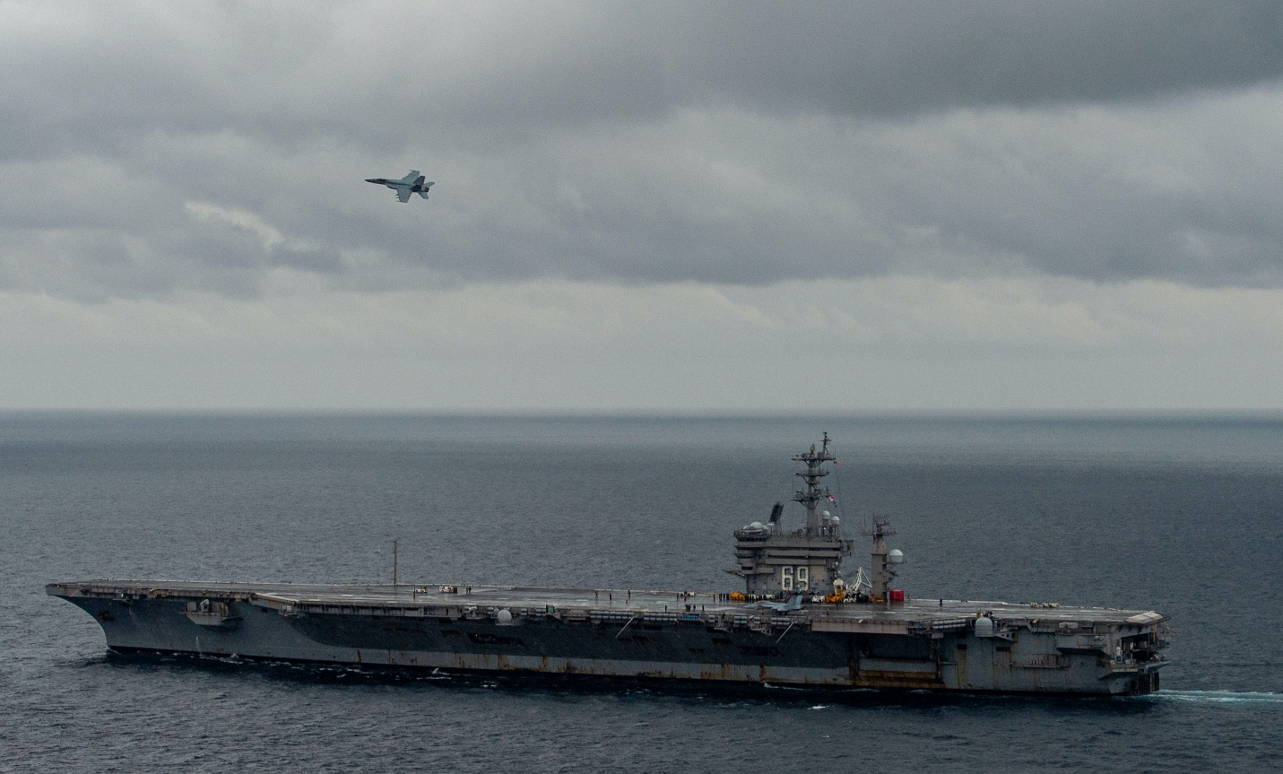

**Scenario situation**:

You, as **Commander of the USS Eisenhower CVBG** have been directed to position yourself between Norway and Iceland to ensure there is no Soviet interference with the ongoing operations to seize the Island and establish a firm base for upcoming operations.

Your CVBG has been in constant operations since the start of the war. Fighting off a Soviet move in the Med, assisting in the defeat of the Libyan Air Force and sinking two submarines, you were then tasked with deploying to the North Atlantic. After a relatively quiet two-day transit towards Gibraltar, you entered the Atlantic 9 days ago and were immediately assailed by heavy submarine and then air activity. The past five days has been hectic as you and the USS Carl Vinson have focused on suppressing defences on Iceland. Yesterday you left that task behind as the amphibious operation was culminating and the task of supporting the Marines was left to the USS Carl Vinson and the USS Theodore Roosevelt. Your carrier has not been in port since a week before the war started, however most of your Battle Group had a chance to rearm while leaving the Med. It has been 4 days since you have replenished, and your stocks of ammunition and aviation fuel are starting to dwindle.

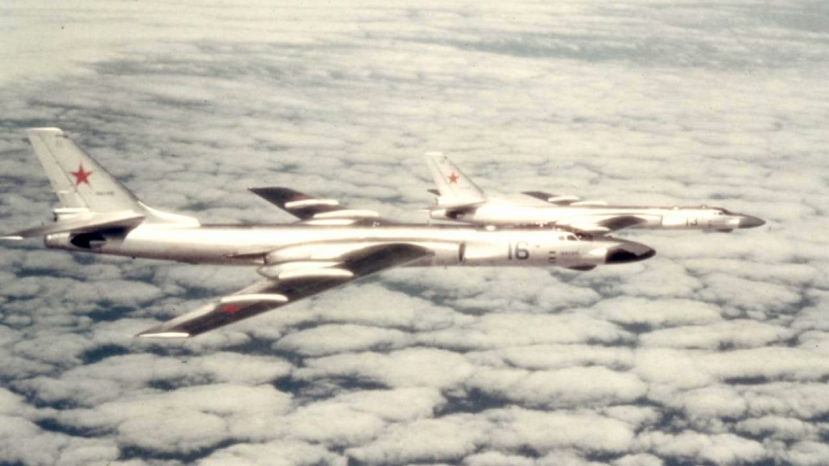

**Northern Fury #27** visits the classic dilemma, often experienced during the Pacific campaign in World War Two, of how best to use naval air power during an amphibious operation. Many advocates of carrier air power state that the best place for a carrier is well beyond the close objective, which is being pummeled by ground and bombardment forces anyway. The idea is that the best way an opponent can interfere with an amphibious operation is from bases that have not yet been attacked, and carriers should be either interdicting that, or attacking those bases. However, the USN’s sea dominance in the North Atlantic during this operation is far less than it was in the Pacific during 1945.

