**Northern Fury 28 - Bump in the Night**

1 March 1994, 2100 Zulu, 2100 Local

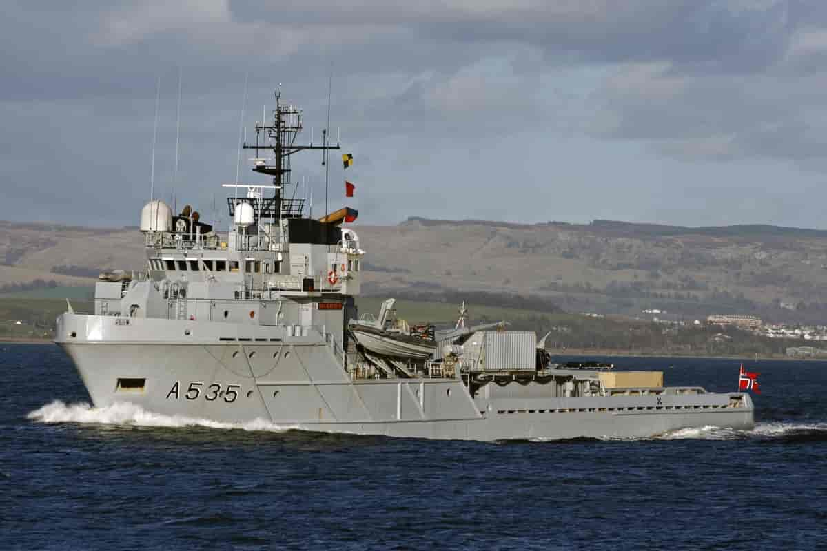

In Norway the Soviets seem to have put their assault on hold. With the main Soviet force on the North side of the Trondheimsfjorden, and the Norwegians defending south of that major water feature. A stalemate has set in, but for NATO supplying elements trapped North of the main line is becoming a problem, however, keeping them there is a thorn in the side of the Soviets.

This scenario is playable by both sides: It should be fast and furious.

As NATO you will be charged with resupplying the isolated coastal fort near Orland, it is on the Northern entrance to the Trondheimsfjorden, and the Soviets need to silence it before their next move. However, it is running out of ammunition, food and many other essential stores. There are Soviet mines in the area, and you want to install two minefields yourself.

As the Soviet player, you are running routine operations to keep NATO under pressure while the next major push is being prepared. You have routine patrols the Norwegians at the Orland fort isolate, and counter mining operations ongoing, there are also Soviet detachments in isolated and vulnerable locations which need supplies.

It is a clear, cold and – so far – quiet night in Norway.

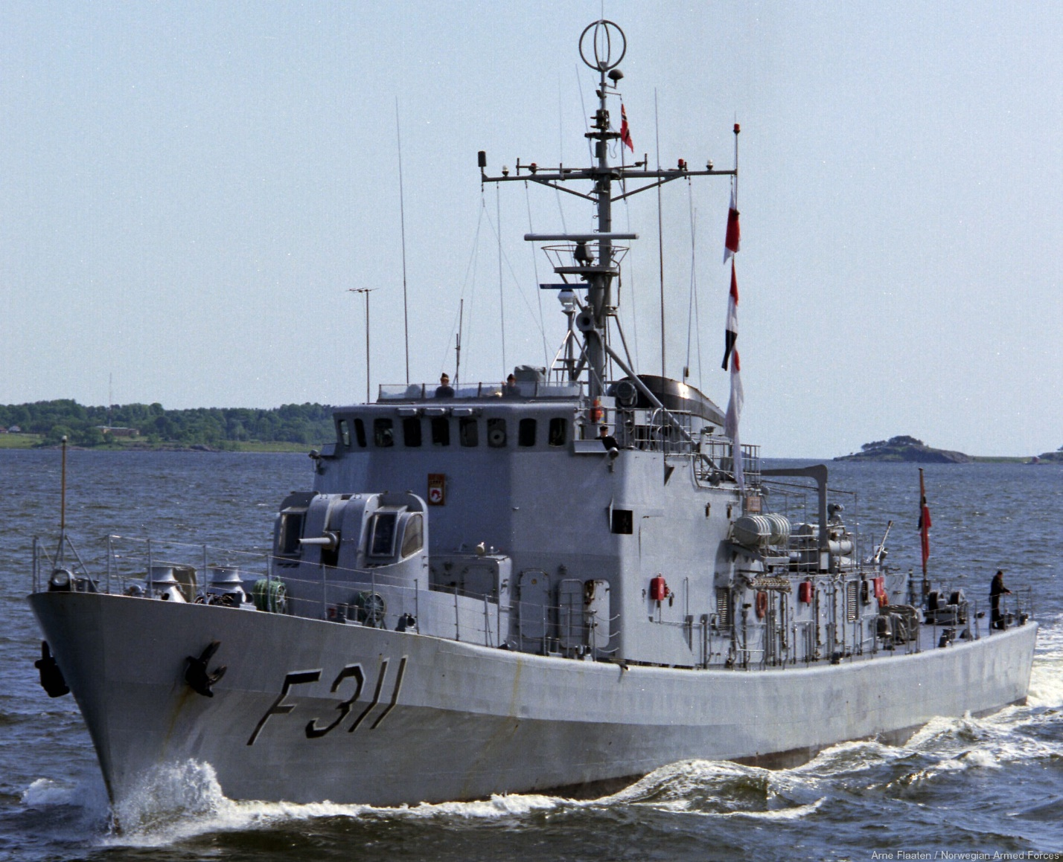

**Northern Fury #28** is a small scenario which can become frantic and at times desperate as both sides strive to complete multiple tasks with limited resources. Sea mines are a deadly threat to both. The night is dark and full of terrors!

