**Northern Fury 29 - Something's Fishy**

9 March 1994, 1830 Zulu, 1930 Local

The fight in Norway has stabilized over the past few days with the main Soviet force on the North side of the Trondheimsfjorden, and the Norwegians defending south of that major water feature. The British Commando Bde has been withdrawn in preparation for future operation. The Air Forces in Norway are sparing daily as more and more force is added on both sides. An attempt to supply elements trapped North of Trondheimsfjorden flared into a major engagement last night, the NATO attempt was thwarted by intense Soviet patrolling with heavy losses on both sides. A major air engagement ensued during the daylight hours of 9 March, and it is widely suspected in NATO that there may be a move – either an attack or a withdrawal from positions north of Trondheim tonight. The Soviets have no intention of withdrawing.

This scenario is playable by the Soviets only:

With the entrance of the Trondheimsfjorden closed by the Norwegian guns at Fort Hysnes, the Soviet Navy has not been able to influence the situation within the massive fjord. The new commander of the 77the Motor Rifle Division (MRD) believes that he can correct the failings of his predecessor by improvising, as such – he has created his own navy! Although the Norwegians either sank or sailed away in many of the vessels in the numerous ports captured in the fjord, there is one type of boat that is so numerous in this area, that a clean sweep was not possible – fishing trawlers!

You are the commander of the 3rd Motor Rifle Regiment (MRR) of the 77th MRD and you have tasked you’re 2nd Battalion to conduct an amphibious assault on the south coast. As you inspect your troops before they embark on this adventure, you can barely hold back a retch at the stink emanating from one of these dilapidated old working boats.

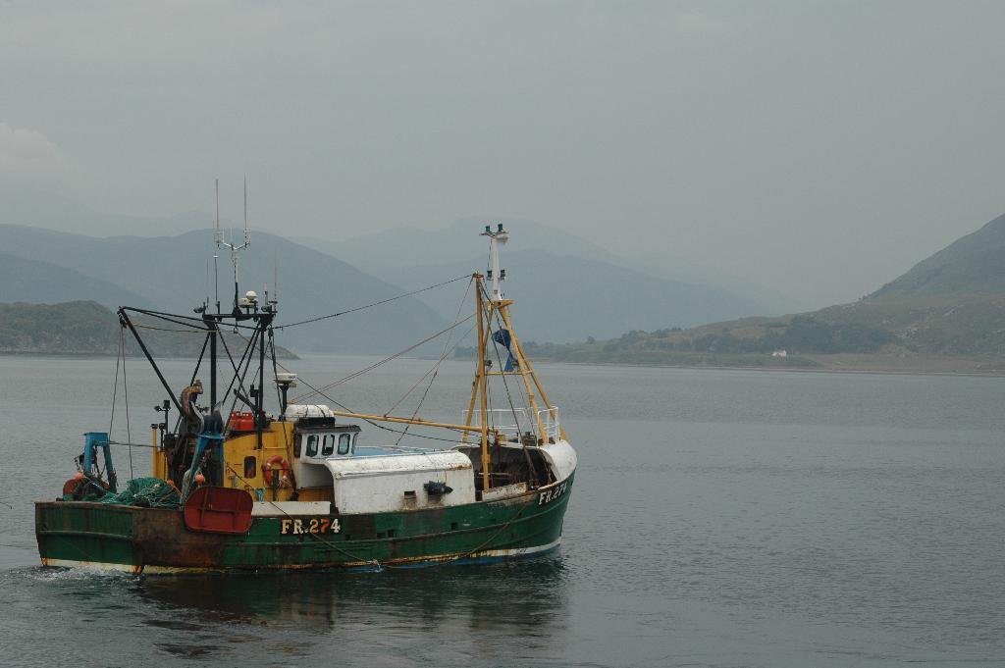

**Northern Fury #29** is quite a different scenario from most others. The player, using stealth and a risky mode of transport must gain a lodgement on the southern bank of the Fjord and repel Norwegian counterattacks supported by artillery and tanks. Success however will break the stalemate.

