**Northern Fury 30 -** **Lance to the Chest**

10 March 1994, 2000 Zulu, 2000 Local

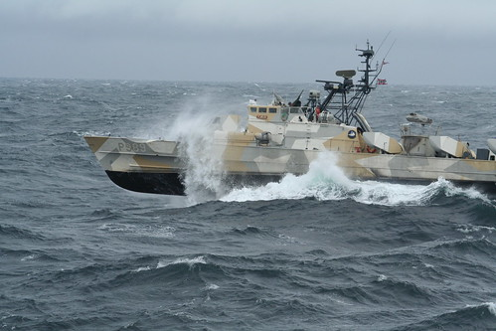

While a surprise renewal of the Soviet offensive south of Trondheim has begun, Bergen is fast finding itself on the front lines

This scenario is playable by either side:

As the NATO commander your job is to patrol the waters off of Bergen Norway and escort Merchant ships into and out of the port.

As the Soviet player your task is to interdict supply ships as they enter the waters off Bergen.

Resources are limited on both sides but neither side can afford a defeat at this stage in the fighting.

**Northern Fury #30** is a classic missile boat battle with roughly equal forces on each side. There are some supporting aircraft on both sides but the key actors are the fast and deadly – but fragile missile boats that the two fleets operate.

