**Northern Fury 31 - Shield of Faith**

10 March 1994, 1800 Zulu, 1900 Local

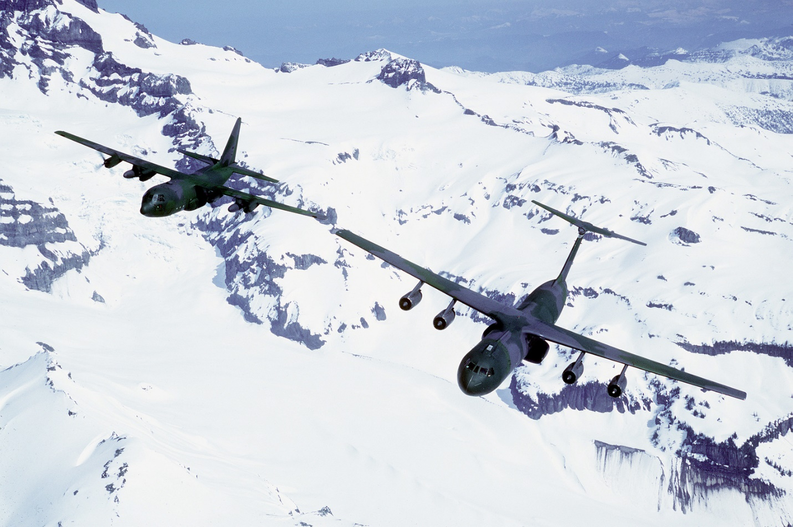

Strike Fleet Atlantic (STRIKFLTLANT) is now in the second phase of its counter attack in the Atlantic. Fighting on Iceland continues but 2 MEF believes that they will have the island clear within the week. The scramble is on to reinforce Norway so that Oslo does not become the third NATO capital to fall in as many weeks.

This scenario is playable by NATO only:

The Soviets have shown strong indications of a renewed attack towards Oslo and NATO needs to reinforce southern Norway in time to stop them. Your job in this scenario will be to manage that reinforcement while protecting some very vulnerable HVU (High Value Units). Time and space are not your friends in this scenario, it’s a race against the clock and the geography surrounding the North Sea is much more limited than that of the North Atlantic, reducing reaction time significantly. Overcrowding of air bases is also an issue – lets hope this all stays nice and conventional!

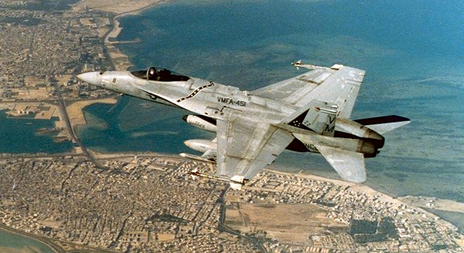

**Northern Fury #31** is a large scenario where management of resources is almost as important as fighting the enemy. Ramp space at Gardemoen airbase north of Oslo is limited so the player needs to stage a large fleet of heavy transport aircraft in and out of the base while keeping only a handful on the ground at any one time. The Shetland Islands is also a focus, an entire US Marine Corps Air Group (MAG) of about 100 aircraft could deploy there, or at the players discretion go to Scotland instead. Heavy reinforcement ships and specialized assets also have to be funneled into this small area. To complicate maters however, most of Denmark is in Soviet hands.

