**Northern Fury 32** **- Sneak & Peek**

10 March 1994, 2000 Zulu, 2100 Local

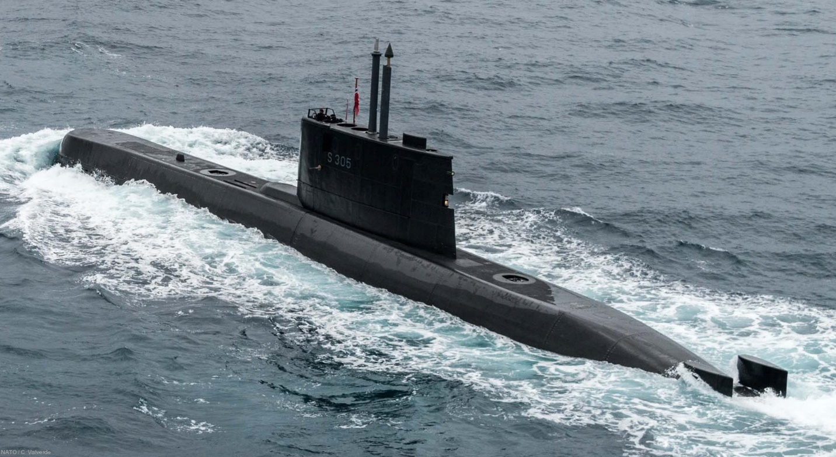

While a surprise renewal of the Soviet offensive south of Trondheim has begun, Soviet supply lines are becoming stretched. As the Soviet ground and air campaign moves south, consuming massive amounts of supplies and resources, the Rear Services group for Archangel Corps struggles to keep pace. For much of Norway’s coastline there is a single two lane road connecting from the Arctic border near Murmansk all the way to Trondheim, over 2000 Km including an 8Km ferry SW of Narvik.

In order to speed the delivery of supplies, coastal shipping is in fairly heavy usage. But that is vulnerable – and your job is to prove just how vulnerable that is.

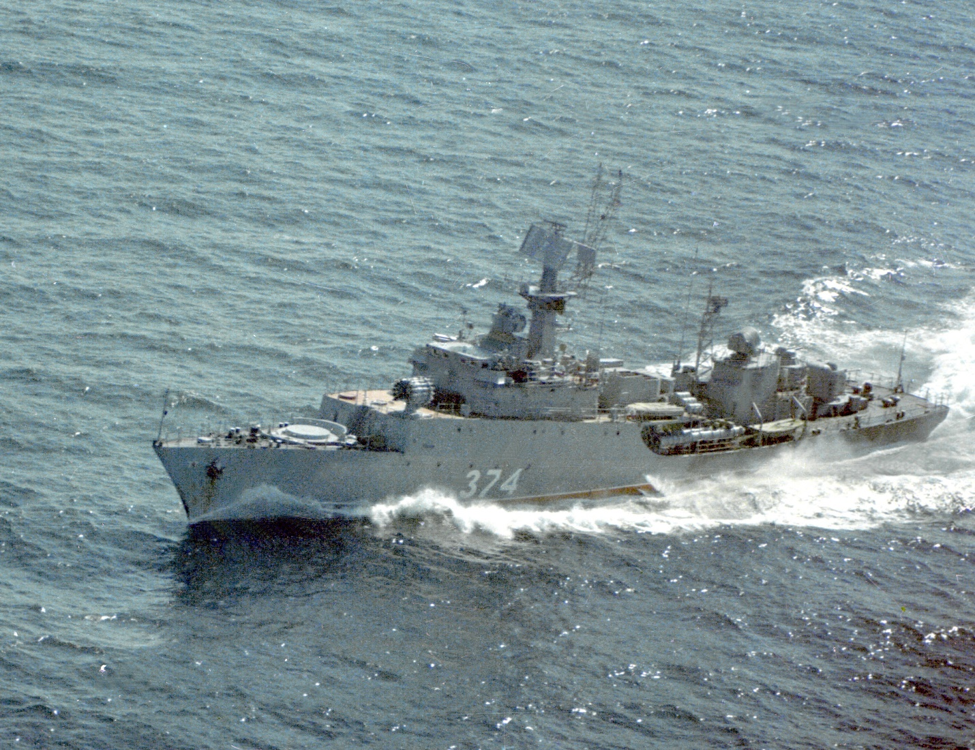

**Northern Fury #32** is a very small scenario. The player is in charge of one submarine, S 305 Uredd, and must sink several merchant ships. The Soviets expect trouble however.

