**Northern Fury 33,** **Into the Night**

10 March 1994, 1300 Zulu, 1500 Local

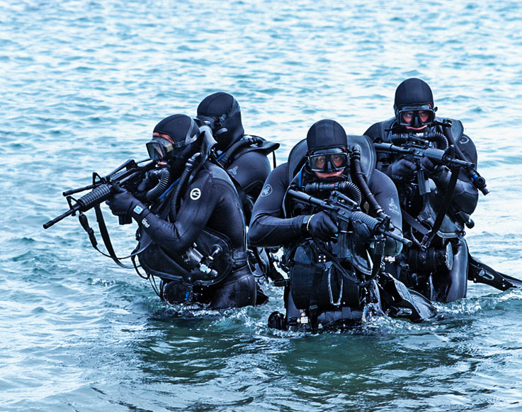

A massive NATO attack will be going in tomorrow aimed at halting Soviet plans to seize Oslo. Under the cover of that operation, tonight’s job is to sneak in and insert several Special Forces teams and link with Norwegian elements in the Soviet rear area.

During the fast-moving Soviet drive to the south of Norway, many small pockets of Norwegian soldiers, home guard, loyal citizens and rugged outdoorsman were left behind. Some have been rounded up and either incarcerated or killed, some have fled to Sweden, and some have frozen to death in the rugged mountains. But most have organized themselves into a very effective force of partisans which have caused significant disruption in the Soviet rear area. This force is centered on the famous Telemark Battalion, which was screening for Brigade Nord when the Soviets bypassed them with airmobile assaults. The battalion simply headed for the mountains, collected every able-bodied civilian and straggler they could find and started attacking the Soviets vulnerable logistics links. After a month of this 'cat and mouse' game, STRIKFLTLANT has decided that they would be a valuable source of intelligence and assistance for upcoming operations, and wants to reinforce them with Special Forces (SOF), communications equipment and information. To this end your task is to insert several SOF teams into Norway’s far north. The Soviets wouldn’t suspect a thing!

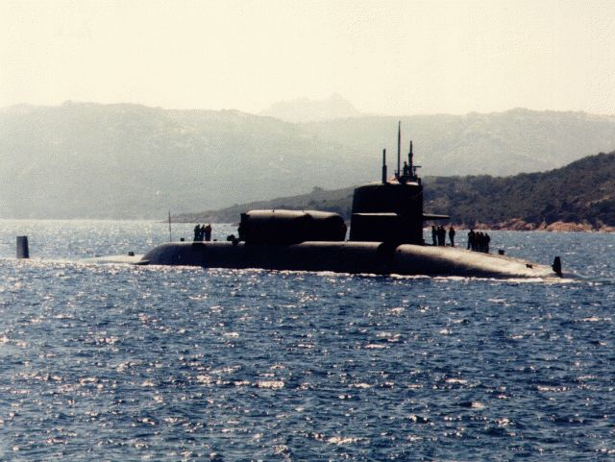

**Northern Fury #33** is a medium sized but complex scenario with many risks. An optional mission is to rescue survivors of a wrecked Norwegian Coast Guard ship, the Nordkapp, a task with several problems but great reward.

