**Northern Fury 34 - The Longest Battle**

23 Feb 1994, 1400 Zulu, 1100 Local

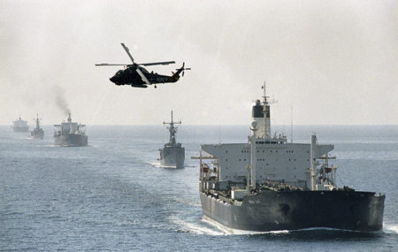

A week into World War III and your life has changed dramatically. As a rather young, newly promoted Rear Admiral (lower half) you were six months into a staff job at the Pentagon, now with a second star on your shoulders, you are in charge of organizing and protecting merchant traffic in the Atlantic! You and your staff of 60 arrived aboard the USS John F. Kennedy 3 days ago in Miami. Fresh after defeating Cuba, Nicaragua and Honduras in an impressive 3-day strike campaign, the Commander and crew of the CVBG is not overly welcoming. They want to be part of the campaign to evict the Russians from Iceland, but instead, they have lost 20% of their hanger space to your HQ (a maze of trailers, shelters and tents for both sleeping and working), and traded in two thirds of the Hornets for more Vikings and Sea Kings.

Because CINCLANT (VAdm Falkner) is heading north with 4 CVBG’s, 2 BB SAGs and the Amphibs accompanied by the British and French carriers and a couple other SAGs, his flagship and staff are quite busy. (See the Northern Fury background document for more details). Therefore, he directed that the John F. Kennedy (CV-67) reconfigure to conduct Sea Control and command all forces securing the SLOC (Sea Line of Communications) between Europe and North America.

Your task is to assemble escorts and aircraft from across the Atlantic, organize hundreds of merchant vessels into convoys and defend them from upwards of 60 Soviet submarines! All this while preventing any escalation of the war, and not losing any of your assets!

**Northern Fury #34** does not fit nicely into any of the phases but is a month-long massive scenario recreating the Battle of the Atlantic round 3! The player is in charge of dozens of dispersed warships ushering hundreds of merchants across the Atlantic.

