**Northern Fury 35 - Shoulder to Shoulder**

11 March 1994, 1400 Zulu, 1400 Local 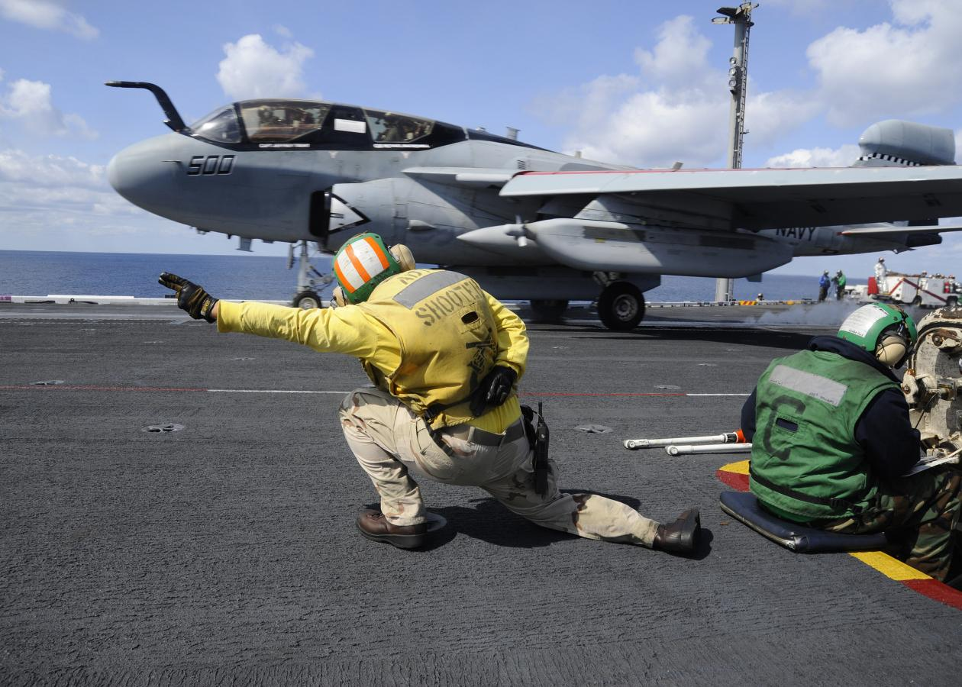

In the past 72 hours’ Soviet forces in Division strength have breached the Trollheimen mountains, the last significant barrier on the approach to Oslo. With Berlin and Copenhagen in Russian hands, and the Norwegian army in tatters the North Atlantic Council (NAC) does not want a third capital city to fall. You, as Commander STRIKFLTLANT have been directed to use all of your available combat power to stop their offensive and to set up the conditions for upcoming amphibious operations in Norway.

You have significant force at your disposal, and initiated movement 2 days ago upon receiving direction from SHAPE to conduct this operation. By acting quickly, you hope to catch the Soviet forces off balance. You intend to hold them in the south while you attack from the west. Time however is not your friend, and the Soviets are a lot closer to Oslo than you are!

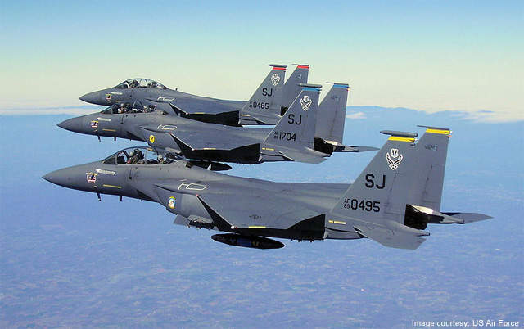

**Northern Fury #35** is a very large scenario where the player is in charge of four US, two British and one French aircraft carrier groups as well as large air forces base on land. Although this is a significant force, it is not overwhelming, and the Soviets have very deep defences.

