**Northern Fury 36 -** **Wrestling an Octopus**

13 March 1994, 0800 Zulu, 0900 Local

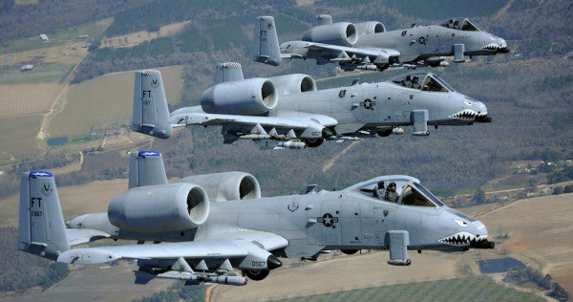

A massive NATO attack two days ago halted Soviet plans to seize Oslo but with Berlin and Copenhagen in Russian hands, the situation is not yet assured. The Soviet Ground Commander in Norway has one final shot in his quiver that will put NATO back on it’s heals and put the Soviets back on the offensive.

You are commanding 2nd Bde, 82nd Airborne Division and have recently been deployed out of Theatre Reserve to Norway in a last-ditch effort to halt the Soviet advance. Your limited forces are being hindered by a general shortage of ammunition – it will only get worse if you fail!

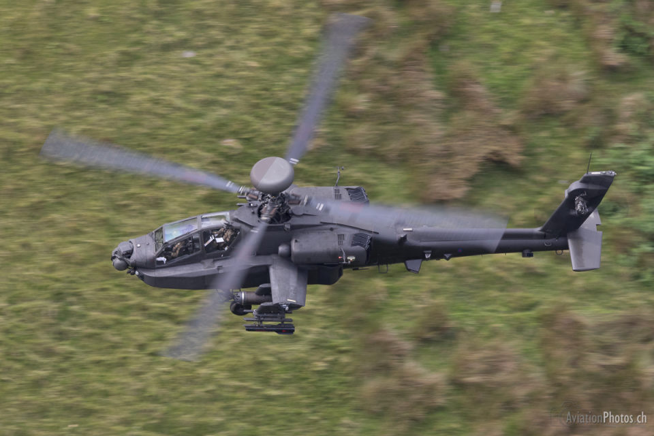

**Northern Fury #36** is a land centric operation where the player needs to use assets available to initiate a JAAT (Joint Air Attack Team) to stop a large a Soviet armored advance. A JAAT is a technique where US Army aviation (Attack and observation Helicopters) supported by artillery and anti-tank fire works closely with USAF strike aircraft, particularly the A-10 in destroying enemy armor in a coordinated killing zone.