**Northern Fury 37 - Charge of the Light Brigade**

13 March 1994, 1600 Zulu, 1600 Local

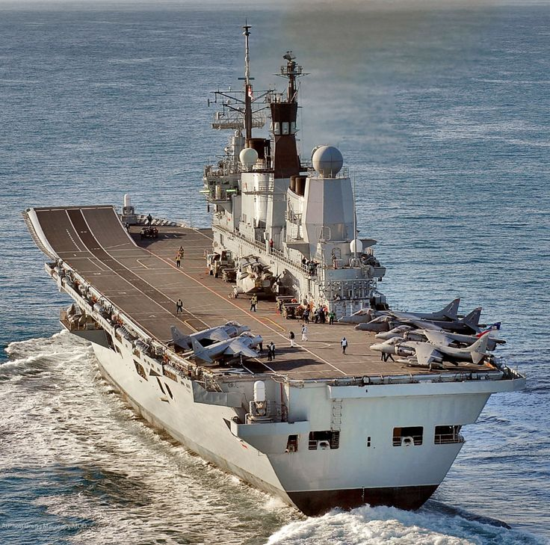

The new global war between East and West has been raging for a month, NATO is on the offensive, but the Warsaw Pact is far from defeated and still has the ability to counterattack. The ground war in Europe continues to be brutal and deadly, after Berlin and Copenhagen fell, the Danish Government collapsed but the Germans continue to govern out of Bonn. Danish air and naval forces are generally still fighting alongside their NATO counterparts, but they have taken heavy casualties. Aircraft losses in central Europe count in the thousands, troops in the tens of thousands on both sides. Over 100 ships and patrol vessels have been sunk in the Baltic alone.

Commander STRIKFLTLANT has set in motion a series of attacks designed set up the conditions for upcoming amphibious operations in Norway – Operation Thor’s Lightning. This is one of those actions.

You are commanding TF 20.3 centered on the two Royal Navy Carriers and a strong surface force. Along with strong but mixed air support you are charged with neutralizing the bases of Orland and Vaernes while focusing Soviet attention. The enemy needs to be looking at you when Thor’s Hammer falls tomorrow.

**Northern Fury #37** is challenging scenario where the player is in the role of commanding a deception force. By there very nature the tasks given are meant to attract attention, but if successfully completed will aid future operations as well.

