**Northern Fury 38 -** **Hammer**

14 March 1994, 1800 Zulu, 1800 Local

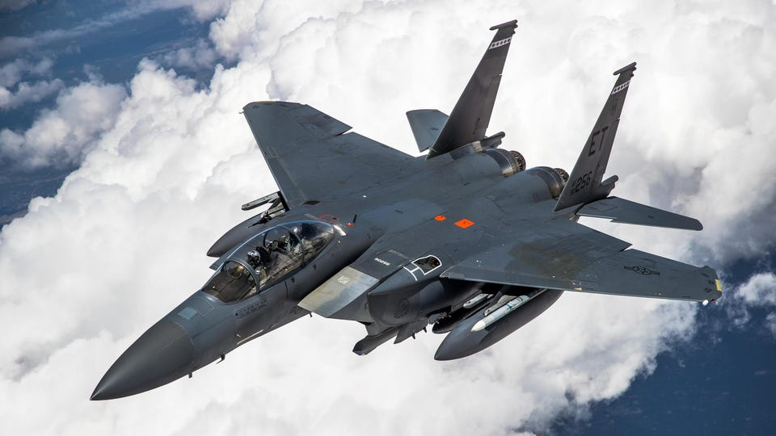

It is now time to start strangling the Soviet forces in central and southern Norway.

You are commanding the USAF’s 336th Fighter Squadron – ***The Rocketeers***, and your mission is to sever the only ground link through central Norway – the E6 Highway. Several elements of 25th Air Force will be supporting you, in particular SEAD and OCA support from 81st Tactical Fighter Wing and some of the heavies from Scotland, but this is your time to show what your ‘Eagles’ can do. The Army is under heavy pressure in the Lillehammer area, and we need to cut the tail of the force attacking them. Timing is a key issue, The Royal Navy is wrapping up a major operation to draw Soviet attention, this should leave you a window to get in and get out quickly – before the USN takes over and takes out the airfields. Your bosses had hoped the Air Bases would be closed by now – but no such luck; you will need to fight all the way in, and out…

**Northern Fury #38** is an exercise in precision bombing using the very new (for 1994) F-15E. Soviet defences are weakened and distracted but not defeated.

